Submit a Protocol (PI)

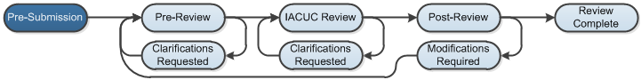

Work Instructions:
- Log into Click Portal.
- Click the IACUC tab at the top and then select your research team from the Research Teams tab.
- Open the protocol from the Submissions tab.
- Click Submit.
- Click OK to certify the statement and submit the protocol. The protocol advances to Pre-Review.

