Click® IACUC 7.2
IACUC Reviewer’s Guide

December 2014

Table of Contents
Logging In 3
Automatically Logging In 3
Getting Started for Reviewers 4
Locating Your Assignments 5
Understanding My Inbox 6
Accessing a Submission 7
Locating Meeting Agenda Items 8
Viewing the Submission Details 9
Requesting Clarifications to a Submission 11
Viewing Changes to a Submission 13
Adding Comments for Other Reviewers 15
Submitting a Review Decision 16
Submitting a Concern 18
Filtering and Sorting Data 18
Finding More Information 20

Logging In
The IACUC system is secure, which means only authorized individuals have access to it. When you log in to the system, you get a personalized view of the information and possible actions pertinent to you.
To log in:  - If you do not see the form shown to the right, click the Login link located at the top right corner of your screen.  - Type the user name and password you received into the boxes. | 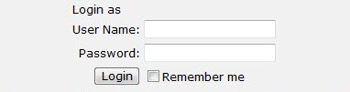
Tips: Press the Tab key after typing your user name to move to the Password box.
If you do not know your user name or password, contact the IACUC for assistance.

- Click Login (or press Enter).

Automatically Logging In
You can set the IACUC system to log you in automatically when you access the IACUC web site.
Important! Do not enable autologin if you are using a shared or public computer. Autologin could cause a security breach by allowing others to take actions as though they were you.

To turn on autologin:  - The next time you log in, check the Remember me box before clicking Login. | 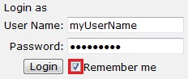
To turn off autologin:  - Click the Logoff link in the upper right corner.  - Click Clear Autologin. | 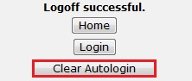

Getting Started for Reviewers
As a veterinarian, IACUC staff member, committee member, or ancillary reviewer, you may be called to review protocols at different times during the IACUC review process. During your review (except ancillary reviews), you may go through a "back and forth" with the protocol team to clarify information in the protocol before making your review decision.
Ancillary reviewers can review the submission and submit their decision with any comments they may have about the submission.
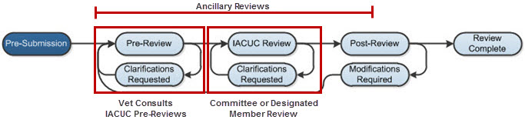
Once the protocol is approved, you may also review follow-on submissions (amendments, annual reviews, or triennial reviews) for that protocol. Regardless of the type of submission, the review activities are the same.
To review a submission:
- Find your review assignments. See Locating Your Assignments on page 5.
- Open the submission and review the details. See Viewing the Submission Details on page 9.
- For Veterinarians, IACUC Staff and Committee Members Only:
  - Request clarifications and changes from the protocol team, if needed. See Requesting Clarifications to a Submission on page 11.
  - Review changes made by the protocol team in response to your clarification requests. See Viewing Changes to a Submission on page 13.
- (Optional) Add comments about the submission for other reviewers. See Adding Comments for Other Reviewers on page 15.
- Submit your review decision. See Submitting a Review Decision on page 16.

Locating Your Assignments
IACUC protocols and follow-on submissions that are assigned to you for action will appear in My Inbox. You may also receive an e-mail with a link to the submission. The e-mail indicates that you must take action or informs you of important information.
For Committee Members: There are some cases where a submission may not appear in My Inbox. Follow your institution's procedures for reviewing submissions in the following states.
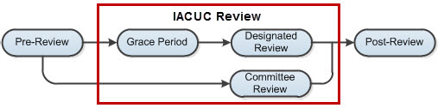
- Grace Period - Protocols in the Grace Period state do not appear in any committee member's inbox. See Accessing a Submission on page 7 to find protocols in the grace period.
- Committee Review - Submissions going through a full committee review will only appear in My Inbox if an IACUC staff member specifically assigns it to you. Regardless if it shows in My Inbox, you will receive an e-mail notification with the meeting agenda. Refer to the links in the e-mail to access the submissions you need to review before the meeting.
To access submissions assigned to you:
- When you log into the IACUC system, you will be on the My Inbox page. If not, click the My Inbox link in the top right navigation header.
- Identify the reason the submission appears in My Inbox by looking at the State column. For an explanation of the action required of you, see Understanding My Inbox on page 6.
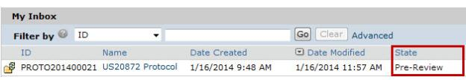
- Click the name of the submission to open it.
To view the details of the protocol, click View Protocol on the left. (See Viewing the Submission Details on page 9.)

Understanding My Inbox
My Inbox lists the submissions that require your attention and action to move them to the next step in the workflow. See the table below for examples of submissions that will appear in My Inbox. To find a submission that is not in My Inbox, see Accessing a Submission on page 7.

Your Role | In My Inbox
 | State | Action Required
Veterinarian | Vet Consult | The IACUC staff has requested a veterinarian consultation. Review the submission and submit your response back to the IACUC. You can also add reviewer notes to protocol pages, which the IACUC staff can pass onto the protocol team.  You can also request clarification from the protocol team. When the protocol team responds to your request for clarification, review their response and submit your decision to the IACUC about whether you accept the submission.
Ancillary reviewer | From Pre-Review through Post-Review | You have been selected as a reviewer (either by name or representing a specific organization) by the protocol team or IACUC staff. Review the submission and submit your decision.  The IACUC may begin its review before you submit your review. The IACUC may or may not wait for your input before completing its review of the submission.
IACUC committee member | Designated Review | The IACUC chair has designated you as the sole reviewer of this submission. Review the submission and submit your final review decision to the IACUC. If you request clarification from the protocol team, the submission will return to you (My Inbox) after the team has responded to your request so you can finish your review.
 | Committee Review | The IACUC coordinator has assigned you as a committee reviewer. Review the submission details before the IACUC committee meeting. If you request clarification from the protocol team, the submission will return to you (My Inbox) after the team has responded to your request so you can finish your review.
IACUC coordinator  IACUC director | Pre-Review | Review the submission and submit a pre-review form indicating if the submission should go to a full committee review.  All IACUC coordinators and directors will see these submissions in their inbox unless a specific coordinator is assigned to the submission. In that case, only the assigned coordinator (see Coordinator column in My Inbox list) will see the submission in their inbox, but all coordinators and directors can still review the submission.  Note: See the IACUC Staff Guide for a complete list of submissions (states and required actions) that will appear in My Inbox.

Accessing a Submission
You may want to view a submission, submit it for review, or take other action on it.
Note: Your role in the system affects your access to protocols and follow-on submissions and the activities you can perform in different submission states.
To open a submission: Click the name of the submission to open it.
To find a submission: Try the following suggestions.

For... | Check... | How to find this list
Submissions assigned to you, for example:  - For PI and team members: A submission you are currently working on  - For reviewers: A submission assigned to you to review | My Inbox | When you log into the IACUC system, you will be on the My Inbox page. If not, click the My Inbox link in the top right navigation header.
Submissions that are:  - In Grace Period state  - Awaiting meeting or reviewer assignments  - Undergoing review and clarification (pre-review by IACUC staff, veterinarian consult, IACUC full committee or designated member reviews, etc.)  Submissions for which an IACUC decision has been made but not yet communicated to the protocol team | IACUC Submissions In-Review tab | Click IACUC in the top left navigation area and select the In-Review tab.  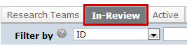
Approved submissions | IACUC Submissions Active tab | Click IACUC in the top left navigation area and select the Active tab.
Discarded or closed submissions | IACUC Submissions Archived tab | Click IACUC in the top left navigation area and select the Archived tab.
All submissions that you have permission to view | IACUC Submissions All Submissions tab | Click IACUC in the top left navigation area and select the All Submissions tab.  Tip: Try filtering this list by the protocol name:  - Next to Filter by, select Name.  - Type the beginning of the name.  - Click Go.

Locating Meeting Agenda Items
As a committee member participating in a full committee review, you can prepare for a committee meeting by reviewing the meeting agenda and the submissions to be covered in the meeting.
The notification e-mail you received for the meeting will have links to the meeting agenda and related submissions. Alternatively, if you already have the IACUC software open, you can navigate to the agenda and submissions.
To access the agenda from the notification e-mail:
- Open the meeting agenda notification e-mail.
- Click the appropriate link:
- To access the meeting workspace containing links to the submissions, click the link next to Link.
- To open or save the meeting agenda document, click the link next to Description. The agenda is in Microsoft Word format.
Tip: Microsoft® Word documents open differently in different web browsers. If the document does not open promptly:
- Click the Word icon if it is flashing at the bottom of your screen, and then click one of your open Word documents.
- Check the bottom of the browser window to see if the document icon and name is shown there. If so, click the name to open it.
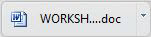

Note: The IACUC meeting workspace will have the most up-to-date agenda as the agenda may have changed since the notification was sent.
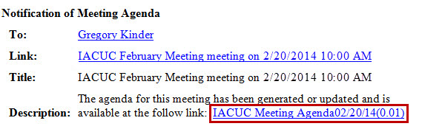
- If prompted, log into the IACUC system.
To access the agenda by navigating to it:
- Click the Meetings link on the left.
- Click the name of the upcoming meeting.
- In the meeting workspace, click the appropriate link:
- To open or save the meeting agenda, click the agenda link at the top of the workspace. The agenda is in Microsoft Word format.
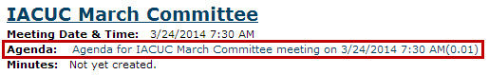
Tip: Microsoft® Word documents open differently in different web browsers. If the document does not open promptly:
- Click the Word icon if it is flashing at the bottom of your screen, and then click one of your open Word documents.
- Check the bottom of the browser window to see if the document icon and name is shown there. If so, click the name to open it.

- To access a submission directly from the Agenda Items list, click the submission ID or submission name.
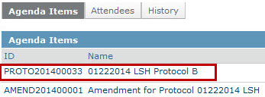

Viewing the Submission Details
As a reviewer, you will need to look at all information related to the submission, including the submission pages and attached documents. You can review the submission online or print it out to review.
To begin, first open the submission you want to review. See Accessing a Submission on page 7.
To view submission pages:
- Click View... (View Protocol, View Amendment, etc.) on the left.
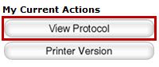
- Use the Continue and Back buttons in the top bar (and the Jump To navigation option if needed) to move through all of the submission pages.
See section below on viewing experiment details.
To view experiment details:
There are several ways to view a protocol's experiments:
- On the Experiments page of the protocol, click the experiment name to drill down to the details. You can also click any procedure name to see its details. Note: The procedure name indicates if it is a standard or team procedure so you can easily identify the institution-approved procedures (standard) from those created by the protocol team.
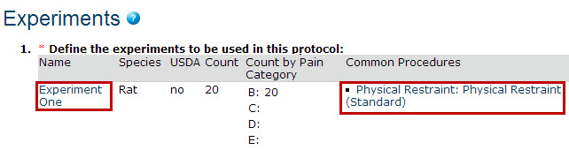
- On the submission workspace, click the Experiments tab to see a list of experiments along with the procedures and substances included in the protocol. Click a procedure or substance to open it.
To view documents attached in the submission:
There are several ways to view documents included in a submission:
- As you look through the submission pages (using the steps in the previous section), when you come across an attached document, click the name of a document to open it.
- On the submission workspace, click the Documents tab to see a list of all the documents attached in the submission. Click the name of a document to open it.
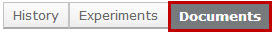
Tip: Microsoft® Word documents open differently in different web browsers. If the document does not open promptly:
- Click the Word icon if it is flashing at the bottom of your screen, and then click one of your open Word documents.
- Check the bottom of the browser window to see if the document icon and name is shown there. If so, click the name to open it.

To print submission pages:
- On the submission workspace, click Printer Version on the left.
Tip: With the printer version displayed, you can search it by pressing CTRL+F or Command+F (Windows and Macintosh, respectively) and typing your search term. You can also view a particular section, by clicking a link in the Table of Contents (top right) to jump to that section.
- Click Print at the top.
An abbreviated version of the protocol prints to your default printer. The printer version shows each page in the submission followed by appendices that list the procedures, substances, and experiments.
Tip: In the appendix, you can identify each new procedure, substance, and experiment as follows:
- Procedures: The prefix "Procedure Identification", for example, Procedure Identification: Blood Draw
- Substances: The prefix "Substance Information", for example, Substance Information: Acetone
- Experiments: The experiment name, for example, Control
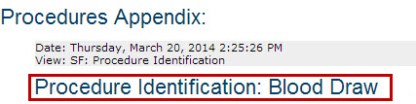

Requesting Clarifications to a Submission
As a veterinarian, IACUC staff member, or committee member, you can ask the protocol team to clarify or change information in the submission by adding reviewer notes to specific pages of the submission. Note: Ancillary reviewers cannot add reviewer notes; instead, they can add comments about the submission when they submit their ancillary review. See Submitting a Review Decision on page 16.
Using reviewer notes will enable the protocol team to address any issues with the submission quickly and appropriately. There are two types of reviewer notes—one that requires a response from the PI and one that doesn't. The PI must respond to all notes requiring a response to move the submission forward in the workflow. As you review a submission, you may see notes added by other reviewers. Notes added by committee members are always anonymous.
To request clarification of specific submission pages:
Follow these steps to add notes to specific pages of the submission:
- From My Inbox, click the name of the submission to open it.
- Click View... (View Protocol, View Amendment, etc.) on the left.
- Navigate to the page where you want to add a note. Note: You cannot add reviewer notes to a specific procedure or substance in a submission. Instead, add a note on the Experiments page with your comments about the experiment's procedure or the substances used in the procedure.
Tip: Use the Continue and Back buttons in the top bar (and the Jump To navigation option if needed) to move through all of the submission pages.
- Click Add in the Reviewer Note bar at the top of the page.
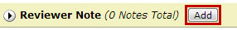
- From the Type list, choose a note type. You can choose a note that requires a response from the PI or one that doesn't. If the note requires a response from the PI, the PI must respond to it before the PI can move the submission forward in the workflow.
Note: The note is considered "draft" until you submit the request for clarification or approve the submission with modifications required. Once submitted, you won't be able to edit your reviewer notes, but you can view them.
- Type your submission comments in the Note box and click OK.
Tip: If you need to update or change what you just wrote, use the options in the Reviewer Note bar at the top of the page:
  - To delete the note, click Delete.
  - To edit the note text, click the link under the Type column.
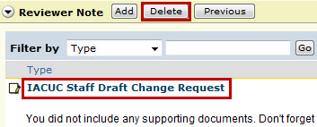

- When done adding notes, click the Exit navigation option at the top.
- Click the Request Clarification... activity on the left.
- Review the notes that you added (at the bottom of the page). To let the protocol team know you added reviewer notes, type a comment in the text box such as "See reviewer notes." This text will appear in the submission's history and the protocol team will see it upon opening the submission. When ready to submit the notes, click OK.
The notes appear in the submission history, however, they will be removed when the submission is approved, discarded, or withdrawn.
You will receive an e-mail notification when the protocol team submits their response to your clarification request (unless the submission is in full committee review).

To request a general clarification about the submission:
Follow these steps to provide general comments about the submission. Where possible, use reviewer notes so the protocol team can respond quickly and appropriately to your requests. See the steps in the section above for adding reviewer notes.
- From My Inbox, click the name of the submission to open it.
- Click Request Clarification... on the left.
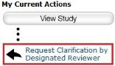
- In the Request Clarification form, type your question or request for changes to the submission.
Note: You can also attach documents that explain your comments, show examples or screen captures of problematic areas, or provide suggestions for resolving the problems.
- Click OK to submit your feedback.
You will receive an e-mail notification when the protocol team submits their response to your clarification request (unless the submission is in Full Committee Review).

Viewing Changes to a Submission
If the protocol team made changes to their submission in response to your clarification request, you will want to determine what changed since you last reviewed it. To figure out what changed, review the clarification request comments (and responses to your reviewer notes). You can also view the Change Log to see all changes made to the submission by person and date or compare two versions of the submission to see what changed on specific pages.
Tip: If the institution allows IACUC staff to edit protocols in addition to protocol team members, you may want to identify who made each change. See the steps below to view the Change Log.
To view responses to a clarification request:
- From My Inbox, click the name of the submission to open it.
- Click the History tab. In the Activity column, look for Response Submitted and any comments the PI may have added.
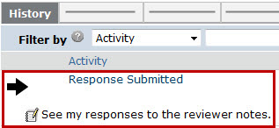
- If you added reviewer notes to the submission, click the Reviewer Notes tab on the submission workspace and review the PI's responses to your notes.
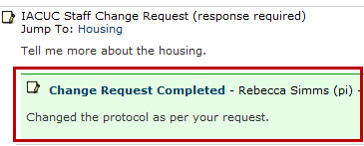
- To view the submission page related to the reviewer note, click the Jump To link. Exit the submission when done.
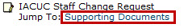
Tip: From within the submission, you can click Previous and Next on the Reviewer Note bar to move through the reviewer notes. You can also hide the reviewer notes to make it easier to view the protocol by clicking the arrow on the left of the Reviewer Note bar.
Important! You have not submitted your review yet. When you are ready to submit it, see Submitting a Review Decision on page 16.

To view the Change Log:
The Change Log only shows changes after the submission has entered Pre-Review state. For approved protocols, the Change Log shows only the changes made on the initial submission; changes from amendments show on the Change Log for the amendment.
- From My Inbox, click the name of the submission to open it.
- In the submission workspace, click the Change Log tab. The tab lists the protocol page, the item on the page that changed, the original and new values, who made the change, and when.
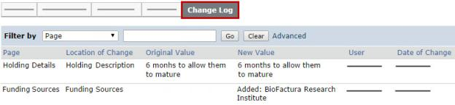
Tip: Use the Filter By feature to find specific data. See Filtering and Sorting Data on page 18.

To view changes between two versions of a submission:
- From My Inbox, click the name of the submission to open it.
- Click View Differences on the left.
- Next to "Show Changes made...", select the version to compare to the current version.
- Look for red and green changes in the current form.
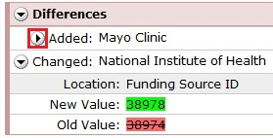
Click the arrow to show the details and new and old values. The changes since the previous version appear as follows:
  - Added text is highlighted in green.
  - Deleted text is highlighted in red with a line through it.
- Next to Changed Steps, click the arrow (or use the drop-down list) to view each of the other forms that have changed.
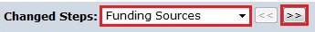
- Exit the View Differences screen by clicking Close on the right.

Adding Comments for Other Reviewers
You may want to add comments for other reviewers to see when they review the submission. When you add a comment, it will appear in the submission's history. You can add regular or private comments to a submission. Regular comments are viewable by any IACUC software user that can view the submission, including the protocol team, while private comments are only viewable by other reviewers (vet, IACUC staff, committee members). Private comments do not display on the History tab for protocol team members.
If you want to add comments for the protocol team within the pages of the submission, do so by adding reviewer notes to the submission. See Requesting Clarifications to a Submission on page 11.
Note: The IACUC staff, IO, and PAM coordinator can view private comments on concerns.
To add comments to the submission:
- From My Inbox, click the name of the submission to open it.
- Click Add Comment to add a comment that all IACUC users can see or Add Private Comment to add a comment that only reviewers can see.
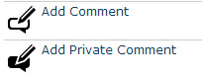
- Type your comments.
- Select any roles related to this submission that should receive an e-mail notification when you click OK. No one will receive duplicate e-mail messages about your comment.
- Click OK.

Submitting a Review Decision
After reviewing a submission, you must submit your review decision in the system. This step completes the review and moves the submission forward in the IACUC process.
For committee reviews: An IACUC staff member must submit the decision on behalf of the committee.
Tip: You can include comments when you record your decision. If you need the research team to answer a question before you can record a decision, request clarifications as described in Requesting Clarifications to a Submission on page 11.
Procedures for the following reviews are identified below:
- Vet consult
- Ancillary review
- Designated review
- Committee review
Note: The procedures below assume that the protocol team has completed any requested clarifications and responded to all reviewer notes that require responses.
To open the protocol:
- From My Inbox, click the name of the submission to open it.
- Choose the appropriate action below.
To complete a veterinarian consultation:
- Click Submit Vet Consult on the left.
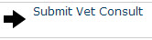
- (Optional) Add any comments and attach documents related to the review.
- Indicate whether you think the submission is acceptable as it is currently written.
- Click OK.
The submission will move back to the IACUC coordinator.
To complete an ancillary review:
- Click Submit Ancillary Review on the left.
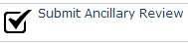
- Select the review you are completing from the list.
- Indicate whether you think the submission is acceptable as it is currently written.
- (Optional) Add any comments and attach documents related to the review.
- Click OK.
The review comments are shown in the protocol history.
To complete a designated member review:
If you feel the submission should be reviewed by the full committee, do not submit your designated member review. Instead, assign the submission to committee review using the Assign to Committee Review activity.
Tip: If the information entered for pre-review is inaccurate, contact the IACUC coordinator to request a change. The coordinator can change some of the pre-review information until the decision from designated or committee review is submitted. Make sure it is corrected before you submit your review decision.
- Click Submit Designated Review on the left.
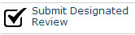
- Select your determination.
- If you are approving the submission, select the approval date, otherwise leave it blank.
- If you require the protocol team to modify their submission to secure approval, type those details in the "If modifications are required..." text box.
- (Optional) Add any comments and attach documents related to the review.
- If you are ready to submit your decision, select Yes. Otherwise, select No, which enables you to return to this form later to edit and submit it.
- Click OK.
To complete a committee review:
Important! An IACUC staff member must submit the decision on behalf of the committee.
Tip: If the information entered for pre-review is inaccurate, contact the IACUC coordinator to request a change. The coordinator can change some of the pre-review information until the decision from designated or committee review is submitted.

- Click Submit Committee Review on the left.
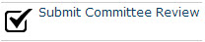
- Select your determination.
- If the committee approved the submission, select the approval date (this will most likely be the committee meeting date), otherwise leave it blank.
- If the committee is withholding approval or requires changes to the submission to approve it, type those details in the "Identify the modifications required..." text box.
- (Optional) Type the number of votes for each determination.
- (Optional) Add any comments and attach documents related to the review.
- Click OK.
The IACUC can now officially communicate the decision to the protocol team.

Submitting a Concern
Any Click IACUC user role (Study staff, IACUC coordinators, directors, committee members, etc.) can enter a concern or report of non-compliance about the research facilities or personnel involved in the care and use of animals.
To submit a concern:
- From the My Inbox workspace, click Create Concern on the left.
- Complete the required questions marked with a red asterisk (*). Click Continue to move to the next page.
- When done, click Finish.
The concern has not yet been submitted for IACUC review. IACUC staff or a committee member must submit the concern to move it from Pre-Submission to Pre-Review.

Filtering and Sorting Data
Many pages contain tables you can filter and sort to help you find the data you want.
- Filtering reduces the list to only the data that meets the criteria. The advanced filter lets you combine multiple filter criteria together.
- Sorting displays the data in ascending or descending order by a particular column
For some reports, you can change the criteria used to create the report before you apply additional filters or change the sort order.
Note: For details on using Advanced Reports, see the Advanced Reports Quick Reference guide.
To filter data:
- Select the column to filter by from the drop-down menu. The menu lists only the columns you can filter by. Note: To combine multiple filter criteria, such as, ID, name, and Date Created, use the advanced filters.
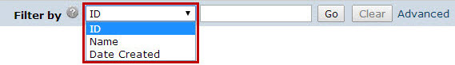
- In the next box, type the beginning characters for the items you want to find. If you do not know the beginning characters, type a % symbol as a wildcard before the characters. Examples:
- 71 shows all items beginning with 71
- %71 shows all items containing 71 in any position
Tip: For examples and a list of operators you can use, click the Help icon. 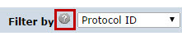
- Click Go to apply the filter.
The table shows only those rows that are an exact match.
Tip: If you do not see the expected items in the list, click Clear in the Filter By area to remove the filter.
To use advanced filters:
- In the Filter By area, click Advanced.
- Enter filter criteria as explained in the previous section. To add criteria, click Add Another Row.
- Click Go to apply the filter.
The table shows only those rows that match all the filter criteria.
To sort data:
Click the column header you want to sort by. Click it a second time to reverse the sort order. The arrow indicates the column by which the data is sorted and the sort order, either ascending (up arrow) or descending (down arrow). Note: If the column header is not a link, you cannot sort by that column.
To change the criteria of the report:
- On the right of the Filter by area, click Change Parameters.
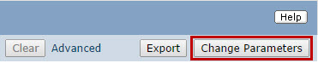
- Change the report criteria field values as needed. Typically, multiple criteria rows (see example 2) are treated with an "and" between them. That is, the report will show items that meet criteria 1 and criteria 2.
- Example 1: Shows all projects that are not archived (!= means the field is not the specified value).
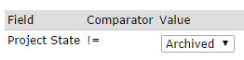
- Example 2: Shows projects that will expire in the next 90 days, that is, the expiry date must be before or on "today plus 90 days" and the expiry date must be today or later. For these fields, you can select different dates using the calendar.
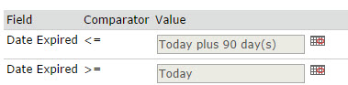
Tip: For a list of the operators you can use in the parameter criteria, click the Help icon.

- Click OK.

Finding More Information

Resource | Description | Location
Help for a field or page | More information about a question or form. | Click next to the question or page title.
IACUC Researcher's Quick Reference | A quick reference guide for PIs and research teams with steps for creating and submitting protocols and follow-on submissions. | - Click the Help Center link on the left.  - On the Guides tab, click the name of the guide to open it.
IACUC Reviewer's Guide | A guide for reviewers with steps for reviewing a submission and submitting a decision.
IACUC Staff Guide | A guide for IACUC staff, inspection officers, PAM coordinators, and training coordinators that includes process overviews, basic administration activities, and tasks for managing and handling inspections, concerns, and training.
IACUC Videos | Conceptual videos to help you understand and use the IACUC software. | - Click the Help Center link on the left.  - Click the Videos tab.  - Click the name of the video to run it.

© 2012-2014 Huron Technologies Inc. All rights reserved. Use and distribution prohibited except through written agreement with Huron.

Click is a registered service mark of Huron Consulting Group, Inc. All other trademarks, registered trademarks, service marks, and trade names are the property of their respective owners.

Information in this document is subject to change without notice.

Published by Huron Technologies Inc.
1925 NW AmberGlen Pkwy
Suite 400
Beaverton, OR 97006

