Navigation Tasks

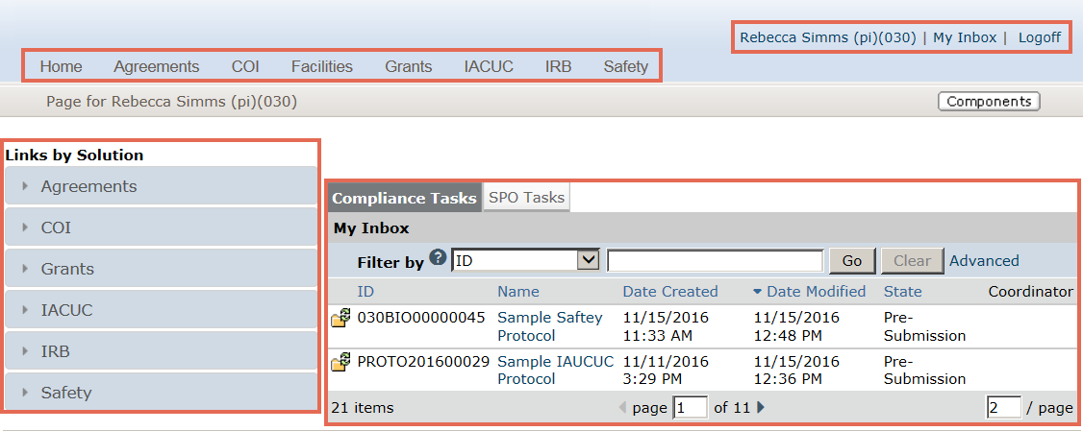
D
C
B
A

My Inbox
This is the My Inbox page. My Inbox is a personal page that lists projects that require action to move forward. Think of My Inbox as your to-do list.
- This section lists the projects that require action to move forward. The projects come from all the solutions in your system. The example shows protocols from both Safety and IACUC.
- This is the header. The header contains a link to the My Inbox page. The My Inbox link is almost always available.
- This is the top navigator. Click the name to go to that solution.
- This shows the links by solution. Click on a link to show the actions available to you for that solution.

Basic Tasks from My Inbox
How do I:
- Open a submission: Click on the submission name and the submission opens to the workspace.
- Determine the state of a submission: Check out the State column. The state column tells you the state, which suggests what you’ll do next. For example, Pre-Submission means that you haven’t submitted the protocol. You can finish and submit it for review.
- Determine the actions that I can perform: Click on the Links by Solution buttons to see the actions you can perform for that solution.
- Return to the My Inbox page: Click the My Inbox link in the upper right hand corner.

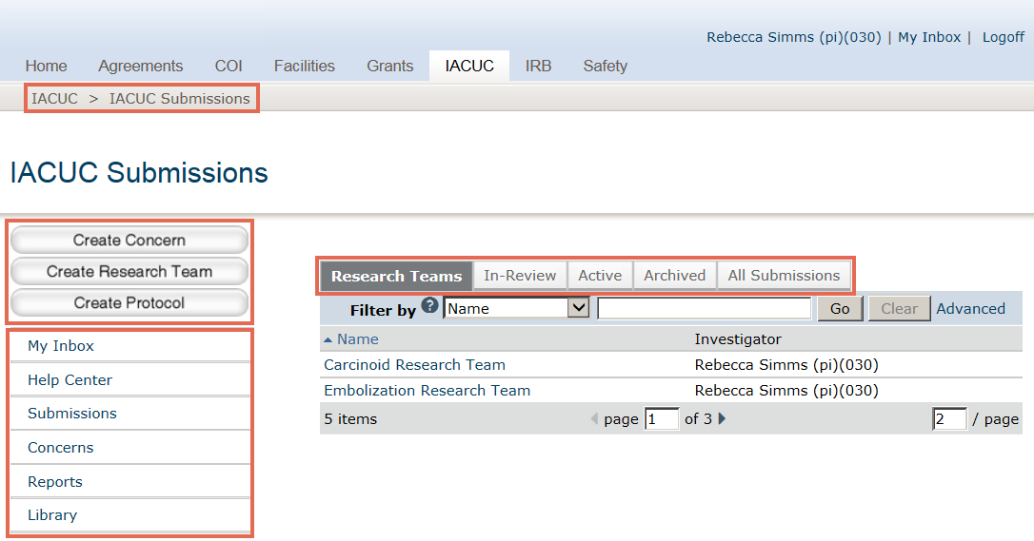
A
B
D
C

IACUC Submissions
This is the IACUC Submissions page. The IACUC Submissions page collects all the IACUC studies that you have permission to see.
NOTE: Studies that require action to move forward are found on the My Inbox page or on your research team’s workspace.
- These are resource tabs. The resource tabs collect information.
  - Research Teams – This tab shows the research teams that you’re on.
  - In-Review – This tab shows submissions undergoing IACUC review.
  - Active – This tab shows approved submissions.
  - Archived – This tab shows discarded and closed submissions.
  - All Submissions – This tab shows all submissions, in any state.
- This is the breadcrumb trail. The breadcrumb trail shows where you are in the system and can be used to find your way back to your starting point.
- These are project creator buttons. You will use these buttons to create a concern, a research team, or a protocol.
- These are shortcuts. A shortcut takes you to that page.
  - My Inbox – This shortcut takes you to your My Inbox page.
  - Help Center – The Help Center provides program documentation and videos.
  - Submissions –The submissions page collects all the IACUC studies that you have permission to see.
  - Concerns – This shortcut takes you to concerns and deficiencies.
  - Reports – This shortcut takes you to reports. Reports only include studies that you have permission to see.
  - Library – This tab is primarily used by other solutions, but it may contain documents used by your IACUC.

Basic Tasks from the IACUC Submissions Page
How do I:
- Start a protocol: Open your research team’s study workspace, then start the protocol.
- See the status of a protocol that is in the hands of the IACUC: Click the In-Review tab.
- Get help: Click the Help Center tab.

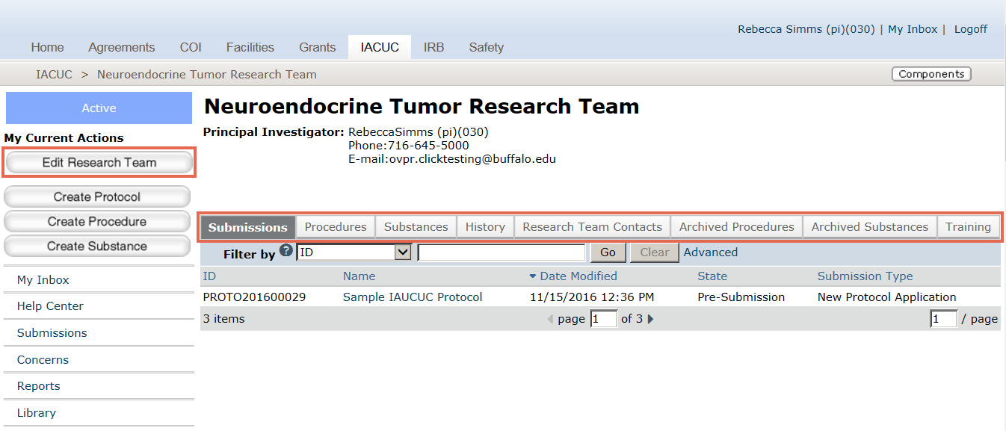
B
A

Research Team Workspace
This is a research team workspace. Protocols are created from a research team’s workspace.
- These are resource tabs. The resource tabs collect information.
  - Submissions – This tab shows all the submissions for this research team, from pre-submission to closed.
  - Procedures – The tab shows procedures from the standard library and team procedures.
  - Substances – This tab shows substances from the standard library and team substances.
  - History – This tab shows all of activity for this research team.
  - Archived Procedures and Archived Substances – This tab shows procedures and substances that are no longer being used.
  - Training – This tab shows training for each research team member.
- This is the Edit Research Team button. Use Edit Research Team to make changes to the research team.

Basic Tasks from the Research Team Workspace
How do I:
- Find a study submitted by my research team: Click the Submissions tab.
- Determine the procedures and substances that are available for my research team: Click on Procedures or the Substances tab.
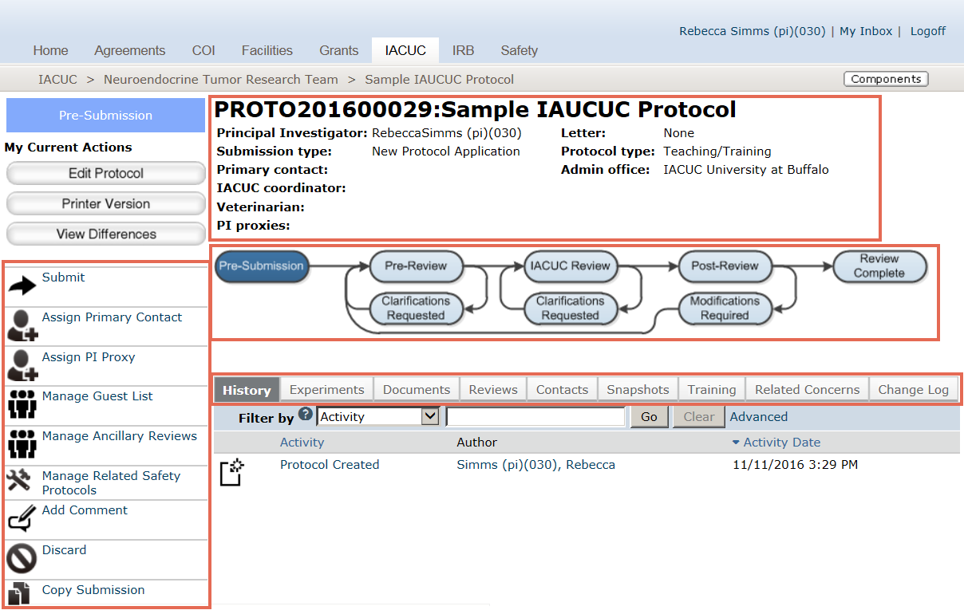
D
C
B
A

Study Workspace
This is a study workspace. All the information regarding a protocol is collected in the study workspace.
- Summary View – The summary view summarizes critical information about the protocol.
- Workflow Map – The workflow map shows the current state of the protocol.
- Resource Tabs – The resource tabs collect information about the protocol.
  - History – This tab shows the history of the protocol.
  - Experiments – This tab shows the experiments
  - Documents – This tab provides links to the documents associated with this protocol
  - Reviews – This tab displays reviews that you have permission to see based on your role.
  - Contacts – This tab lists the contacts for the study.
  - Snapshots – Snapshots are moments in the workflow captured by the system.
  - Training – This tab lists training of the research team members.
  - Related Concerns – This tab lists concerns that were submitted that are associated with this protocol.
  - Change Log – The change log shows any changes made after the initial submission.
- Activities – These are the activities that are available to you on this submission while the submission is in this state.

Basic Tasks from the Study Workspace
How do I:
- Learn what has happened since a protocol was submitted: Click the History tab.
- Access protocol documents: Click the Documents tab.
- Learn the name of the IACUC Coordinator assigned to my protocol: Look in the Summary View.

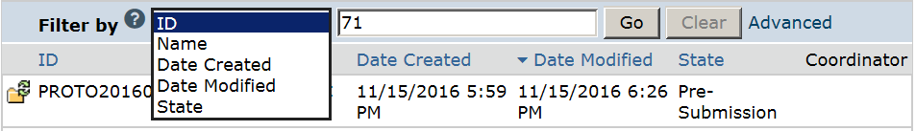
A
B
E
D
C

How to Filter Data
This is a filter. Any time you see a filter, you can use it to filter data.
- Select the column to filter by.
- Use the (?) Help Icon to learn about the different operators you can type in (C).
- Type the beginning characters for the items you want to find. You can type a % symbol as a wildcard before the characters. For example, 71 shows all the items beginning with 71, whereas %71 shows all the items that contain 71.
- Click Go to apply the filter.
- To combine multiple criteria at the same time, click Advanced.

