Submit Proposal to Sponsor (Grants.Gov)

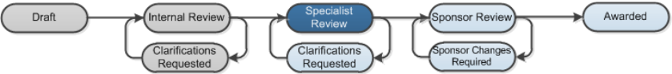

Work Instructions:
- Log into Click Portal.
- From your Inbox, on the SPO Tasks tab, open the proposal in Final SPO Review.
- From the proposal workspace, in the Proposal Information area at the top, click the SF424 link.
Note: The SF424 must be in the Valid for Submission state to submit it to Grants.Gov. If it isn’t, validate the SF424 and fix any errors. Steps for updating and validating the SF424 are covered in other work instructions.
- From the SF424 workspace, click Submit to GrantsGov and then OK to send the SF424 application to Grants.Gov. The system sends an email to the proposal team and the submitting department that the SF424 has been submitted to the sponsor.
Note: The SF424 will move through different states as the two systems (Grants and Grants.Gov) communicate back and forth. The final state “Federal Funding Agency Tracking Number Assigned” indicates the SF424 application was successfully submitted to the Grants.Gov system.
- At the top (under the Grants tab), click the proposal name breadcrumb to return to the proposal workspace.
- From the proposal workspace, click Submit to Federal Sponsor and then OK.
The proposal moves to the Sponsor Review phase of the review process (proposal’s state is Pending Sponsor Review). The next step is to update the status of the grant when communication is received from the sponsor. If an award letter is received, then an award can be created for the proposal.
Note: Steps for creating an award are covered in other work instructions.

