Submit Proposal for Department Review

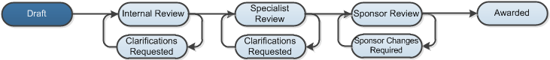

Work Instructions:
- Log into Click Portal.
- From your Inbox, on the SPO Tasks tab, open the draft funding proposal.
- From the proposal workspace, click Submit for Department Review on the left.
- In the pop-up window, click OK to submit the proposal for review.
Note: The system checks that the credit distributions total 100%. If they don’t, an error message appears and you must fix them before submitting the proposal for review. See work instructions for completing credit distribution.
Your funding proposal has been submitted for department review and is now in the Internal Review phase of the review process. You will receive an email if a reviewer has questions about your proposal.

