Request Changes to a Proposal

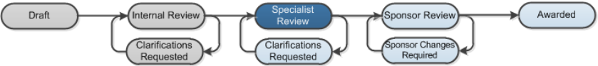

Work Instructions:
To make a change request about a specific proposal page, do so by adding a Reviewer Note to that page.
- Log into Click Portal.
- From your Inbox, on the SPO Tasks tab, open the funding proposal in the Specialist Review state.
- From the proposal workspace, click the View Funding Proposal button on the left and navigate to the page that requires a change
- Click Add in the top left of the Reviewer Note bar.
Note: There is only one Reviewer Note type available (Specialist Draft Change Request.)
- In the Note box, type the changes requested. It is helpful to identify the field or question on the page and the changes required
- Click OK. The Reviewer Note appears at the top of the page. When finished adding Reviewer Notes to the proposal pages, exit the proposal SmartForm.
- From the workspace, click Specialist Requests Changes.
- In the pop-up window, select Department Review Required if the proposal should back through a department review before returning to the Specialist Review state.
- In the Comments box, type text that you want to appear in the email that is sent to the proposal team, for example, “See the Reviewer Notes I added to the proposal pages.”
- Click OK. An email is sent to the proposal team about change request.
The proposal moves to Clarifications Requested.
