Manage and Track Reviews

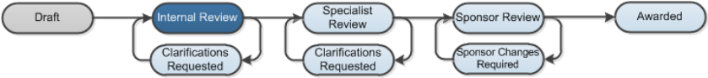

Work Instructions:
These instructions are for pre-award administrative staff members that will manage and track department reviews. These activities are performed during Internal Review when a proposal is in the Department Review state.
Find Proposals in Department Review
- Log into Click Portal.
- From your Inbox, click the Grants tab at the top.
- On the All Single Proposals tab, open the proposal in Department Review. You can filter the data as follows:
- Filter by: Select the column to filter by from the drop-down menu and then type the first few characters for the item you want to find. Click Go. The system returns all items matching the criteria. To apply multiple filters, see Advanced below.
Note: You can also type a % symbol as a wild card before the characters. For example, if you filter by “State” and then type “%Dep” and click Go, the system returns all proposals that are in a state containing “Dep” such as Department Review.
- Advanced: Click the Advanced link to the right of the Filter by feature. Enter filter criteria as explained above. To add more criteria, click Add Another Row. Click Go to apply the filters.
Tracking Department Reviews
The Credit Routing Information tab enables you to track who will be reviewing a proposal and whether reviewers have completed their reviews.
- From the proposal workspace, click Credit Routing Information tab.

- On the Credit Routing Information tab, you will see the following information:
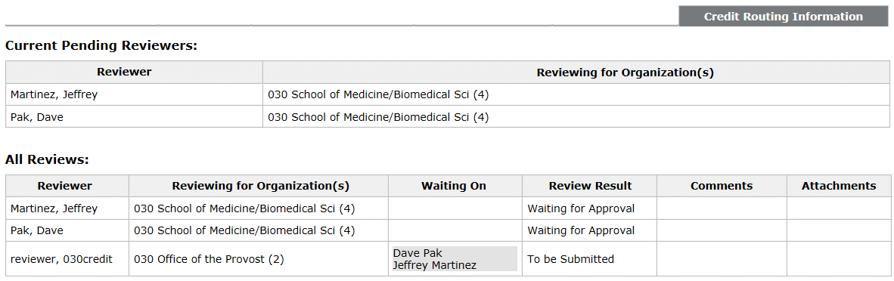
A
B
- Current Pending Reviewers: Lists the current reviewers that are in line to review a proposal. If an organization has multiple review levels, this area shows only those reviewers in the current review level that haven’t yet reviewed the proposal.
- All Reviews: Lists all reviewers involved in the review process. The Review Result column shows the person’s review status (see below) and the last two columns show any comments and attachments added by the reviewer as part of his/her review.
    - Approved: This reviewer has approved the proposal. When a reviewer approves a proposal, it moves to the next reviewer in the Current Pending Reviewers list.
    - Disapproved: This reviewer has disapproved the proposal. When a reviewer disapproves a proposal, it moves back to the proposal team to make changes and resubmit it for review.
Note: The proposal will go through the complete department review process again.
    - Waiting for Approval: This reviewer is part of the current review level.
    - To be Submitted: This reviewer is part of a future review level. The “Waiting On” column lists the reviewers from a previous review level that must first approve the proposal before this reviewer can review it.
    - Bypassed: This reviewer was skipped and the proposal moved to the next person in the review process.

Bypass Department Reviews
These instructions explain how to skip a particular department reviewer or all department reviewers to move a proposal forward in the review process.
- From the proposal workspace, click Bypass Department Reviewer on the left.
- In the pop-up window, select the department reviewer to bypass or select the check box to bypass all department reviewers.
- In the Comments box, type your reasons for doing this and click OK.

A department reviewer must approve a proposal or be bypassed for the proposal to move to the next department reviewer. After the last reviewer approves the proposal (or is bypassed), the proposal moves to Specialist Review.
