Create an Award

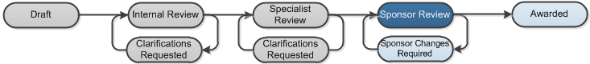

Work Instructions:
- Log into Click Portal.
- Click the Grants tab at the top. On the All Single Proposals tab, open the proposal in the Pending Sponsor Review state.
Note: To find a proposal, you can filter by “State” and then type “%Pending” in the search criteria box. Click Go. The system returns all funding proposals in a state with “Pending” in it.
- From the proposal workspace, click Award Letter Received and enter the award details. Click OK.
- From the proposal workspace, click the Create Funding Award button.
- Complete each page, paying attention to the fields explained below. Click Continue in the Navigation Bar to move through the pages. Required fields are marked with an asterisk (*).
Note: Some fields were auto populated from the proposal; you can update any fields as needed.
- When finished answering all the required fields on the SmartForm pages, on the Completed Award page (last page), click Finish to be redirected to the award workspace.
- When you have finished creating the award, click Activate on the award workspace and then OK to activate the award
The proposal moves to the Awarded state. Next steps might include creating an award modification, such as a revision, or a renewal as the PI reaches the end of project funding. When a project finishes, the award must be closed out.
Note: Steps for creating award modifications, revisions, and renewals, and closing out awards are covered in other work instructions.
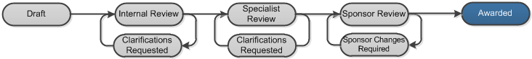

Funding Award
- 9.0 Administrative Contact: Select a department contact that will have access to this award.
- 11.0 and 12.0 Start and End Dates: Update the start and end dates of the award if appropriate.
Award Setup Information
- 1.0 Cumulative Awarded Amount: Enter the total amount awarded by the funding agency for this award.
- 2.0 Funded amount…: Enter the total amount currently awarded.
Terms and Conditions
- Terms and Conditions: Select all the Terms and Conditions that apply.
- Special Terms and Conditions: If there are Terms and Conditions that do not appear in 1.0, click Add to add them manually.
Project Award Budgets
You can set up allocations and reconcile them to budget periods either while you are setting up an award or afterward. Once an award is activated, you must create an award modification to change the award.
Note: Steps for creating an award modification and revisions are covered in other work instructions.
Click Add, Update, or Remove to adjust allocations to match the sponsor’s actual award allocations. By default, when an award is created, the system creates allocations to match the proposal budget periods.
When you click Add or Update, the Edit Funding Allocation page opens. Complete it and click OK.
  - 1.0 Name: The name defaults to “Award Period #
  - 2.0 Description: This is an optional field for additional information about the award allocation.
  - 8.0 Period Number: The period associated with the funding allocations.
Note: If there is a split in the award funds for a period, for example, multiple departments splitting the funds, the allocations will be grouped by the period number.
  - 9.0 Indirect Rate: The indirect rate will be used for indirect rate calculations on the reconciliation page.
  - 10.0 Authorized:
- “Yes” means the sponsor has authorized spending of the allocation. Only allocations with “Yes” will be available to reconcile with a budget period.
- “No” means the amount is a future allocation that must be awarded.

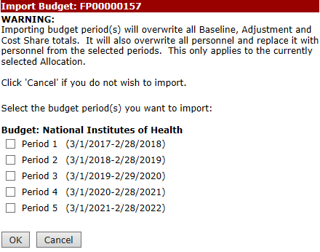
Award/Authorized Budget Reconciliation
C
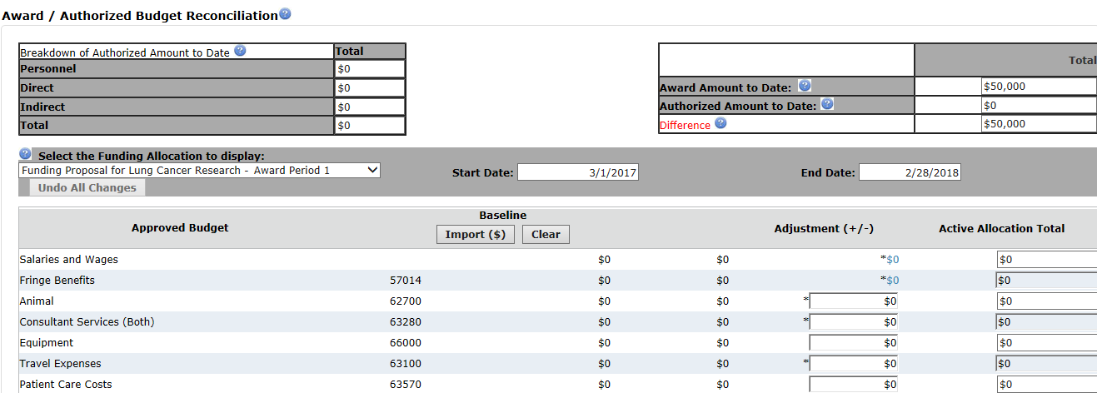
- Select the allocation to reconcile.
A
B
D
E
Note: Only authorized funding allocations will be available for selection.
- Click Import to bring in amounts from the proposal budget.
Note: You can manually type costs into the Adjustment column rather than importing them.
- Select the budget period you want to bring in as a starting point for the award period and click OK. The budget categories are updated with amounts from the selected proposal budget period.
- In the Adjustment column, adjust the imported budgeted amounts so the difference between the awarded and authorized amounts, in the top-right corner, equals zero.
- To adjust salaries or fringe benefits, click the blue hyperlink and add, edit, or remove personnel details as needed.
Repeat the above steps to reconcile other budget period amounts to award allocations.

Deliverables
Deliverables are activities or work assignments that must be completed to remain in compliance with the award Terms and Conditions. Deliverables are assigned to owners and appear on the Deliverables tab of the award workspace.
Click Add to create a new deliverable.
- 1.0 Name: Type a name for the deliverable, for example, “Annual Progress Report.”
- 3.0 Set Number of Occurrences and 4.0 Frequency: The occurrences and frequency allow you to create multiple instances of the deliverable at one time. For example, if the number of occurrences is “3” and the frequency is “Annual”, the system will create 3 instances one year apart, starting with the defined due date.
- 6.0 Responsible Party: Select the primary person responsible for completing the deliverable.
- 7.0 Additional Staff…: Add all users who should receive a reminder email 60 and 30 days before the deadline date.
Compliance Information
This page defaults to values from the proposal. No updates are needed to this page during the initial award creation because most, if not all, compliance has been completed on the proposal.

