Create a Renewal Funding Proposal

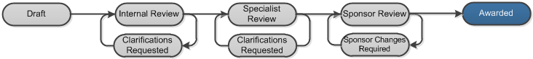

Work Instructions:
- Log into Click Portal.
- Click the Grants tab at the top. On the All Single Proposals tab, open the proposal in the Awarded state.
Note: To find an awarded proposal, you can filter by “State” and then type “Awarded” in the search criteria box. Click Go. The system returns all proposals in the Awarded state.
- From the proposal workspace, click the Create Renewal button.
- Complete the proposal pages. Click Continue in the Navigation Bar to move through the pages. Required fields are marked with an asterisk (*).
Note: See work instructions for creating a funding proposal.
- When finished answering all the required fields on the SmartForm pages, on the Completion Instructions page (last page), click Finish to be redirected to the renewal proposal’s workspace.
Your renewal proposal has not yet been submitted for review. Your next step is to update the credit distribution for the proposal. While the proposal is in the Draft state, you can also perform the following activities from the proposal workspace:
- Continue to update your proposal by clicking Edit Funding Proposal.
- Withdraw your proposal before you have submitted it for review by clicking Withdraw Proposal (Prior to submission to sponsor).
- Email the proposal team or specialist regarding your proposal by clicking Email Proposal Team or Email Specialist.

