Conduct a Department Review

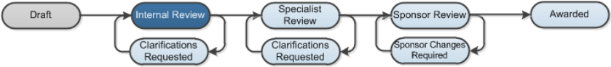

Work Instructions:
- Log into Click Portal.
- From your Inbox, on the SPO Tasks tab, open the funding proposal to review.
- From the proposal workspace, click the Credit Routing Information tab to see the other department reviewers’ determinations and comments.
- From the proposal workspace, click View Funding Proposal to view each page of the proposal or Printer Version to view the proposal in one scrollable page.
- When finished your review, on the left of the proposal workspace, click Review Proposal.
- Select Approved or Disapproved and add any comments or documents related to the review. If you select Disapproved, then type the changes required to obtain approval in the comments box (or attach a document with the changes.)
- Click OK to submit your review.
If the proposal was approved, the proposal moves forward in the process.
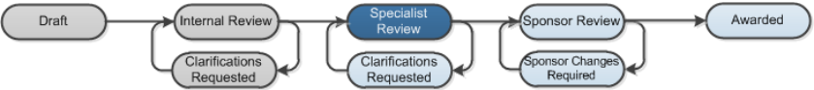
If the proposal was not approved, it moves to Clarifications Requested. The proposal team receives an email with your change requests. After they have made the changes, they can resubmit the proposal for department review.
