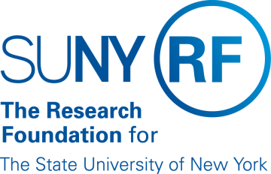
Research Foundation for SUNY
Test Plans for SUNY PACS Grants

Test Description: | 9. Specialist returns to PI for Changes after Departmental review and approval
Tester Location:
Test Executed By:
Tester Email Address:

Test 9: Specialist returns to PI for Changes after Departmental review and approval

Step | Test Steps | Test Data | Expected Results | Notes
1 | Open browser and navigate to https://pacsstg3.rfsuny.org/SponsoredPrograms/login |  | - The SUNY PACS website login page is presented.
2 | Log in as grantsspecialist  (Test accounts have been provided) |  | - Log in is successful  - Inbox displays
3 | Click on Grants (tab on the Top), Prerequisite is to have a proposal in the state of Specialist Review: The proposal has already gone thru Department Review and approval. Click on the proposal name to Open the proposal up. |  | - The proposal page will display  - Status is Specialist Review | NOTE: Save and Continue along the way as you proceed thru the below steps
4 | On the left hand side click on Edit Funding Proposal | None-review proposal details. | - The Proposal details are now available for review.
5 | Return Proposal to PI requesting changes  On the left hand side select Specialist Requests Changes. |  | - Specialist request changes form displays
6 | Specialist Requests Changes  Department Review Required Optional – This determines if the proposal changes have to go back thru department review OR if the changes will just be returned to the specialist and bypass department review.  Comments:  OK | For this test, do not check the box.  Add a comment to assist the PI in his changes. | - Proposal is now back in the state of Specialist Review:Pending changes by PI
End of Test

