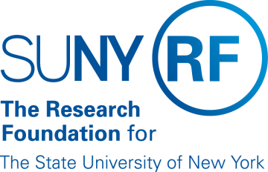
Research Foundation for SUNY
Test Plans for SUNY PACS Grants

Test Description: | 06. Test and validate Department approval with ability to add notes
Tester Location:
Test Executed By:
Tester Email Address:

Test 6: Department Review, Process approval with Notes

Step | Test Steps | Test Data | Expected Results | Notes
1 | Open browser and navigate to https://pacsstg3.rfsuny.org/SponsoredPrograms/login |  | - The SUNY PACS website login page is presented.
2 | Log in as grants approver1  (Test accounts have been provided) |  | - Log in is successful  - Inbox displays
3 | Click on Grants (tab on the Top), In the users Grants In Box user will see the Proposal with the state of DEPARTMENT REVVIEW. Click on the proposal name to Open the proposal up. | Click the proposal name: Your Name- Test 3 Non Grants.gov Proposal | - The proposal page will display | NOTE: Save and Continue along the way as you proceed thru the below steps
4 | On the left hand side click on View Funding Proposal to review the proposal. Scroll thru the pages and select Exit on the top of the menu bar when review is complete |  | - The proposal page will display
5 | Complete Review and Approve  Click on Review Proposal on left of screen, the review proposal page will display.  Add a comment.  Upload attachments (Optional) Click Add  Click OK | Select Approved  Proposal Approved  Upload attachment 11 | - The proposal page will display  - Proposal is now in Specialist review(indicated on process flow as well as the top left of screen)
End of Test

