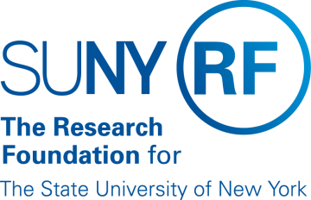
Research Foundation for SUNY
Test Plans for SUNY PACS Grants

Test Description: | 5. Test and validate to ensure that the PI/Study Staff are able to copy an existing proposal and make changes
Tester Location:
Test Executed By:
Tester Email Address:

Test 5: Copy Existing Proposal and make changes

Step | Test Steps | Test Data | Expected Results | Notes
1 | Open browser and paste in https://pacsstg3.rfsuny.org/SponsoredPrograms/login |  | - The SUNY PACS website login page is presented.
2 | Log in as GrantsPI  (Test accounts have been provided) |  | - Log in is successful  - Inbox displays
3 | Click on Grants(tab on the Top), Open Proposal created in test case #3 (This should be listed in the first page where all the proposals are listed) Or any other Proposal | Click on proposal Your Name-Test 3 Non Grants.gov Proposal | - The proposal page will display | NOTE: Save and Continue along the way as you proceed thru the below steps
4 | Click on the Copy Button on the bottom left hand side of the screen. |  | - COPY form displays
5 | COPY Form  Enter a Proposal Name  Use background Processing  Click OK | Enter the new proposal name  Your Name-Test 4 Non Grants.gov Proposal.  Check the box | - Background process submitted | Note: This activity to copy a proposal could take a while depending on the information within the proposal.
6 | Click on Grants on the top tool bar  The NEW proposal will now be listed in the list of Proposals |  | - New Draft proposal created.
7 | Click on the New proposal name to Open the proposal  Select Edit Proposal to Make any changes as needed  NOTE: The copy also copies the Budget if one exists |  | - Changes Made are accepted
8 | Click the submit for department review
End of Test

