Complete a Subaward/Subcontract Budget

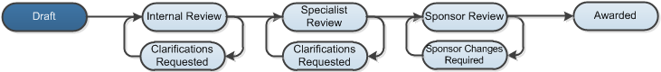

Work Instructions:
- Log into Click Portal.
- From your Inbox, on the SPO Tasks tab, open the draft funding proposal.
- From the proposal workspace, click the Budgets tab and then the name of the sponsor budget that has a subaward/subcontract.
- From the sponsor budget’s workspace, click the Subaward/Subcontract tab.
- Click the name of the subaward/subcontract budget to open it.
- From the subaward/subcontract budget workspace, click the Edit Budget button and complete the budget pages. Pay attention to the fields listed below. Click Continue in the Navigation Bar to move through the pages. Required fields are marked with an asterisk (*).
Subaward/Subcontract Budget Information
- 6.0 Subaward/Subcontract Budget Detail Level: For Grants.Gov submissions, select Full Details. Otherwise, select Per Period, Budget Category Totals.
- When finished answering all the required fields, on the last page, click Finish to return to the subaward/subcontract budget’s workspace.
- At the top (under the Grants tab), click the proposal name breadcrumb to return to the proposal workspace.
Your funding proposal is still in the Draft state. Your next step is to complete any other budgets (other subaward/subcontract budgets or cost sharing budgets) for the proposal. If all budgets, along with the funding proposal, are complete, then:
- Grants.Gov Submissions: Create the SF424.
- Non-Grants.Gov Submissions: Submit the funding proposal for department review.

