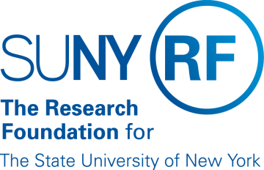
Research Foundation for SUNY
Test Plans for SUNY PACS Grants

Test Description: | 18. Test the ability to Close out an Award
Tester Location:
Test Executed By:
Tester Email Address:

Test 18: Close Out an Award

Step | Test Steps | Test Data | Expected Results | Notes
1 | Open browser and navigate to https://pacsstg3.rfsuny.org/SponsoredPrograms/login |  | - The SUNY PACS website login page is presented.
2 | Log in as Grantsspecialist  (Test accounts have been provided) |  | - Log in is successful  - Inbox displays
3 | Click on Grants (tab on the Top), Click on the All Awards tab. Prerequisite: Find an Award that is in a state of Active.  Click on the Award Name and Open up the Award | Use the award that was made active in Test 13. | - The Awards page will display | NOTE: Save and Continue along the way as you proceed thru the below steps
4 | Click on the Complete button on the left hand side of the screen.  Comments Box: Add any Comments  Click add to add any attachments  Click OK | Award now completed & closed.  Add attachment13. | - Complete form displays  - The Award state is Now Complete | Note: Before closing out an award, please make sure that all criteria is meet for award closure based on campus requirements and the award is also being closed in Oracle Grants.
End of Test

