April 2018
Advanced Reports
Reference Guide
COI

Page left intentionally blank

Click COI – Advanced Reports Quick Reference
Contents
Generate Advanced Reports 3
Open Advanced Reports 3
Filter Data on Reports 3
Export and Print Advanced Reports 4
Export a Report 4
Print a Report 4
COI Turnaround Times 5
Report Filters 5
Chart and Legend Description 5
Days in State 6
Report Filters 6
Chart Description 6
Table Description 6
Submission Volume 7
Report Filters 7
Chart Description 7
Table Description 7

Generate Advanced Reports
Only COI Administrators, Committee Members, and Monitors can access COI Advanced Reports.
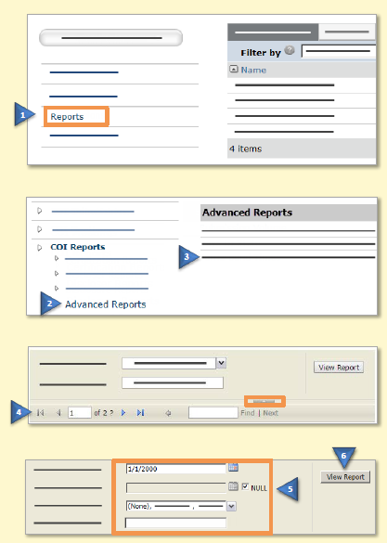 | Open Advanced Reports
- From My Inbox, click Reports on the left.
- Click the Advanced Reports link on the left.
- Click the report name to open it. Expand the report window to see the entire report.
- To view all the pages of the report, use the navigation features in the report toolbar.
Tip: Click the arrow above the report toolbar to hide the Filter options.
 | Filter Data on Reports
- Specify criteria for data on the report:
- Drop-down lists – Click the down arrow and select the data to show on the report. Select ‘(None)’, if available, to include items with no data.
- Dates – Type the date in MM/DD/YYYY format or click the calendar icon and select the date. Select ‘NULL’, if available, to allow all dates.
Note: Some browsers do not support the calendar icon function.
- Click View Report on the right to see data matching your criteria.
Tip: If nothing displays, click View Report again.

Export and Print Advanced Reports
From the report toolbar you can export Advanced Reports to a variety of file formats, such as PDF or Excel.
You can also print the Advanced Reports.
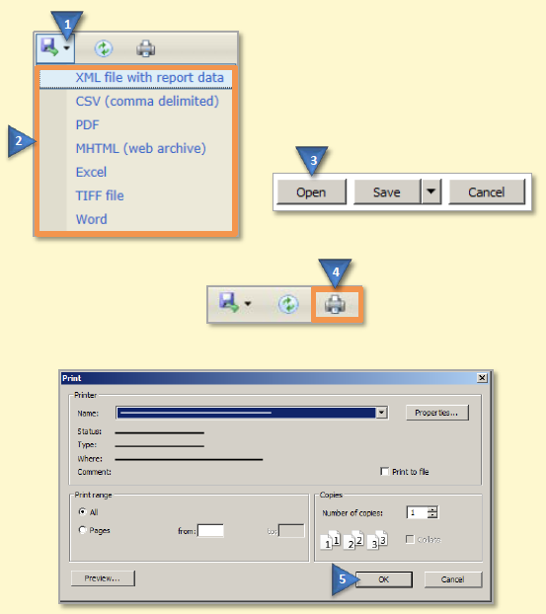 | Export a Report
- In the report toolbar, click the export icon down arrow.
- Select a file format from the list.
- Click Open to save the file or Save to save the file to your computer or network.
 | Print a Report
- In the report toolbar, click the printer icon.
Tip: If you are using Internet Explorer, your version of the web browser may require certain SQL Server Reporting Services add-on software to be installed in order to print the report. If so, follow the browser instructions to install the required software.

- In the Print window, select your print options and then click OK.

COI Turnaround Times
This report shows the average number of days it took for disclosure certifications (DCs)
to go through a complete COI review, from DC creation to final review completion.
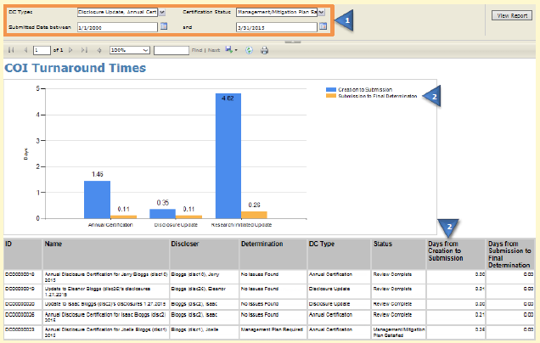
Report Filters | Chart and Legend Description
- You can filter all DCs that have reached review completion on:  - DC Types: The type of disclosure certification reviewed, such as annual, disclosure update, or research-initiated  - Certification Status: The completed state of the DC, such as under management plan  - Submitted Date: The date the DC was submitted for review by the discloser | - For each DC Type, the chart shows the average number of days for a DC to move between these milestone intervals.  Creation to Submission  - From: Date the DC was created  - To: Date the discloser submitted the DC for review  Submission to Final Determination  - From: Date the discloser submitted the DC for review  - To: Date the DC reached a review completion state (Review Complete or Under Management/Mitigation Plan)  Note: DCs in No Review Required state are excluded from this report.

Days in State
This report shows the total and average number of days that DCs were in particular states while completing a COI review.
Use this report to assess workflow efficiency and identify bottlenecks in the review process.
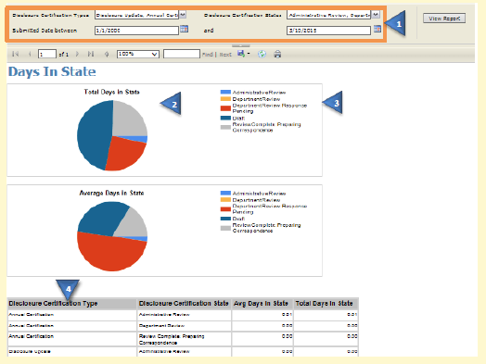
Report Filters | Chart Description
- You can filter all DCs that have reached review completion on:  - Disclosure Certification Types: The type of disclosure certification reviewed, such as annual, disclosure update, or research-initiated  - Disclosure Certification States: The workflow state of the DC during the review, such as administrative review  - Submitted Date: The date the DC was submitted for review by the discloser | - Two charts show the filtered data:  - Total Days in State: The total number of days DCs were in each state  - Average Days in State: The average number of days DCs were in each state  - The legend and chart show only those states selected in the Disclosure Certification States filter. The DCs shown have completed the COI review process, reaching one of these completion states: Review Complete, No Review Required, Under Management/Mitigation Plan, or Management/Mitigation Plan Satisfied.
 | Table Description
 | - Several table rows showing total and average days may appear for each selected state. State data is first separated into rows by DC Type and then by State.

Submission Volume
This report shows the total number of DCs in the system, by DC type.
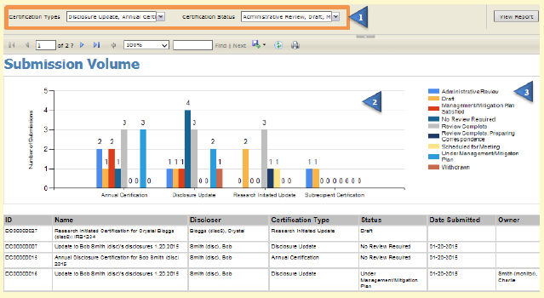
Report Filters | Chart Description
- You can filter all DCs on:  - Certification Types: The type of disclosure certification, such as annual, disclosure update, or research-initiated  - Certification Status: The current state of the DC at the time of generating the report | - The chart shows the number of DCs for each selected DC Type, and includes a bar for each state.  Tip: If the chart contains too many bars, you can filter the States and DC Types to display the data in more management portions.
 | Table Description
 | - The legend and chart show only DCs currently in one of the states selected in the Certification Status filter.

