Clarification Requested

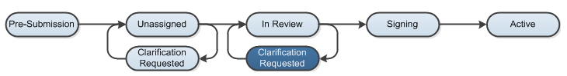

At several points during the review process, the Agreements Manager or Reviewer may request clarifications from the study team prior to making a determination.

Work Instructions:

- Log into the Click Portal and click on the Agreements tab in the top navigation bar.

- Find the submission requiring clarifications in which the state is defined as Clarification Requested (Unassigned) or Clarification Requested (In Review). Click on the agreement’s Name to navigate to the Agreements Workspace.
  - Principal Investigators can also navigate directly to the protocol Workspace by clicking on the link in the email notification and logging into the system

- Review the requested information by clicking on the Clarification Requested activity on the History tab.

- To provide a response, return to the Agreements Workspace and click on Submit Clarifications under My Current Actions. Write your response in the box provided and/or add any additional supporting documentation, and then click OK.

- The response submitted will display in the History log and state of the protocol will return back to either Unassigned or In Review.

