Activate an Agreement

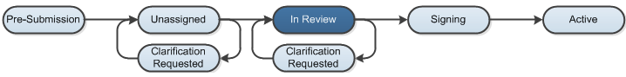

Work Instructions:
Send the Agreement Out for Signing

- Log into the Click Portal and click on the Agreements tab in the top navigation menu.

- Click the All Agreements tab, and then click on the agreement’s Name to open it.

- To send the agreement out for signing, click on Send Out for Signature under My Current Actions.
- Reviewers can elect to collect Internal and External Signatures in any order.
- The organization will pre-populate from the SmartForms. Enter information regarding a specific contact, if necessary.
- Click the OK button.
- The agreement will move to the Out for Signature (Signing) state.

Revise the Agreement

- Log into the Click Portal and click on the Agreements tab in the top navigation menu.

- Click the All Agreements tab, and then click on the agreement’s Name to open it.

- To upload a signed version of the agreement, click on Revise Agreement under My Current Actions.

- Click the Choose File button and upload the signed version of the agreement. The version number will automatically populate.
- Type Notes, if necessary.
- Click the OK button.
- The agreement will not change states.

Convert the Agreement to PDF and Activate It

- Log into the Click Portal and click on the Agreements tab in the top navigation menu.

- Click the All Agreements tab, and then click on the agreement’s Name to open it.

- To convert the file, click on Convert to PDF under My Current Actions.

- Click OK. The agreement will be converted to a read-only PDF document.
- To activate the agreement, click on Activate under My Current Actions.
- Click the Add button, and select an individual that signed the agreement.
- Click OK, and then click OK once more. Repeat the process to add the names of all signatories.

- Enter an Internal signing date and External signing date.
- The Effective and Expiration dates will automatically pre-populate.
- Click OK.
- The agreement will move to the Active state.

