PACS DECENTRALIZED Agreements Review Interaction with RFCO
RFCO Sponsored Programs
Manage Ancillary Reviews Activity
Agreements Reviewer / Agreements Manager at decentralized campus will add RFCO Sponsored Programs as an ancillary review on the agreement. Reviewers (i.e. Nancy Minnich) in the RFCO Sponsored Programs will get a notification. Reviewers (i.e. Nancy Minnich) will log in the system, provide comments and attach necessary information, then submit the review.
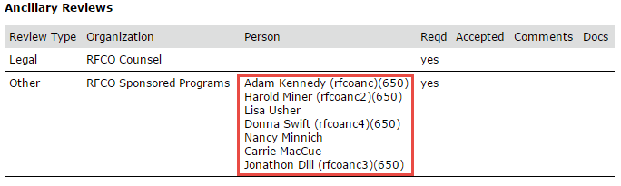
RFCO Counsel, Compliance, Risk
Staff in the RFCO Counsel and Compliance Offices would not use the system directly or receive any notifications from the system. Interaction between campus and RFCO Legal, Compliance, and Risk will remain the same as what campus do presently via email or phone call. But the Agreements Reviewer / Agreements Manager has the ability to track the interaction through the following 2 options.
Option 1: Manage Ancillary Reviews Activity (Recommend)
The process would be similar as RFCO Sponsored Programs. The only difference is that there would be no staff in the RFCO Counsel or Compliance or Risk to notify (see screenshot below). The Agreements Reviewer / Agreements Manager will have to update the ancillary reviews in the system once responses are received from RFCO via email or phone call. We recommend campus to choose this option for future reporting purpose.
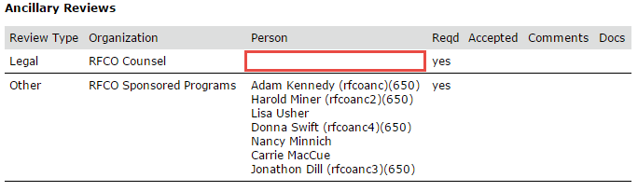
Option 2: Log Correspondence Activity
Agreements Reviewer / Agreements Manager can track interaction between RFCO through “Log Correspondence” activity.

