Workflow States and Transitions
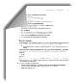
Pre-Submission
Unassigned
Internal Review
External Review
Language Finalized
Routing for Signature
Out for Signature
Active
Agreement Office
PI, PI Proxy, or Study Team
Clarification Requested
Note: Amendments follow a similar workflow to agreements.
Initial State | During This State… | To Move to the next State… | Next State
(No State) | Any user can create a new agreement. | Agreement is saved in the system.  (Study team clicks Continue on the first page of the agreement form or the Save option at the top.) | Pre-Submission
Pre-Submission | Study team can edit the agreement.  Study team can add ancillary reviewers (e.g., department reviewers) to the agreement. | PI or proxy submits the agreement to the  agreement office. | Unassigned
Unassigned | Agreements Reviewer (REV) reviews the agreement. | REV takes ownership of the agreement or assigns it to another user. | Internal Review
 |  | REV requests clarification from the PI about the agreement submitted. | Clarification Requested
Clarification Requested | Study team can edit the agreement in response to the reviewer’s clarification request. | PI submits changes and responds to the reviewer’s clarification request. | Unassigned or Internal Review (returns to the state in which the clarification request  was made)

Initial State | During This State… | To Move to the next State… | Next State
Internal Review | REV can generate the agreement for review.  REV can edit the agreement or upload a revised version.  REV can e-mail the agreement to other Agreements software users to review.  REV can set up correspondence reminders to follow up with internal, 3rd party, or ancillary reviewers.  REV can add and notify ancillary reviewers of their reviews (if present) and update ancillary reviews. | REV moves the agreement to External Review.  Note: REV will move the agreement back and forth between Internal and External Review to reflect who is reviewing the agreement. | External Review
 |  | When all parties agree on the agreement language and all ancillary reviews are completed, REV approves  the language. | Language Finalized
External Review | Same as Internal Review. | REV moves the agreement to Internal Review. See Note for Internal Review. | Internal Review
 |  | When all parties agree on the agreement language and all ancillary reviews are completed, REV approves  the language. | Language Finalized
Language Finalized | REV can upload the final version of the agreement for signature (or confirm final agreement is in the system).  REV can convert the agreement to a PDF if the agreement should be watermarked before signing. | If the institution will sign first, REV routes the agreement for signature. | Routing for Signature (internal)
 |  | If the 3rd party will sign first, REV sends out the agreement for signature. | Out for Signature (external)
Routing for Signature (internal) | REV can upload the final version of the signed document if wet ink signatures were obtained.  REV can convert the agreement to a PDF (if not done before receiving signatures). | Once all internal signatures are received, REV sends the agreement out to the 3rd party for signature. | Out for Signature
 |  | REV moves the agreement to Internal or External Review. | Internal Review or  External Review
 |  | When all signatures have been received, REV activates the agreement (or approves if an amendment). | Active (“Approved” for amendments)
Out for Signature (external) | Same as Routing for Signature. | Once the 3rd party signatures are received, REV routes the agreement for internal signatures. | Routing for Signature
 |  | REV moves the agreement to Internal or External Review. | Internal Review or  External Review
 |  | When all signatures have been received, REV activates the agreement (or approves if an amendment). | Active (“Approved” for amendments)
Active | REV can terminate the agreement.  Study team can create an amendment.

Navigation and Basic Tasks
This section explains where to go to perform basic actions on an agreement.
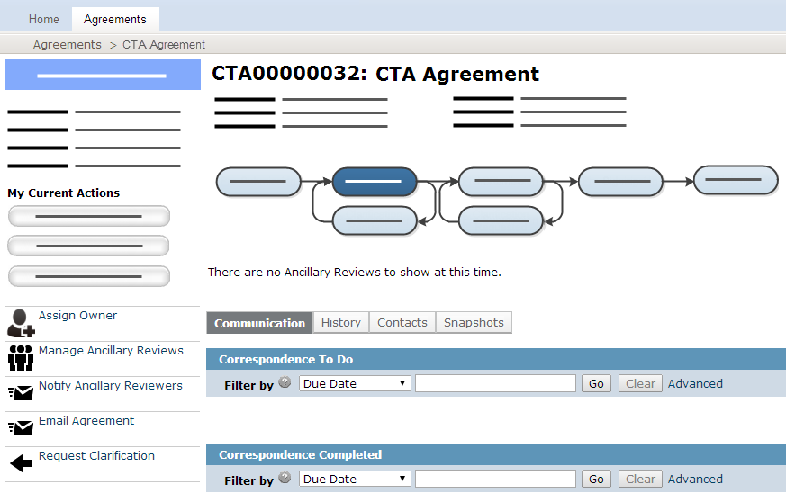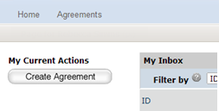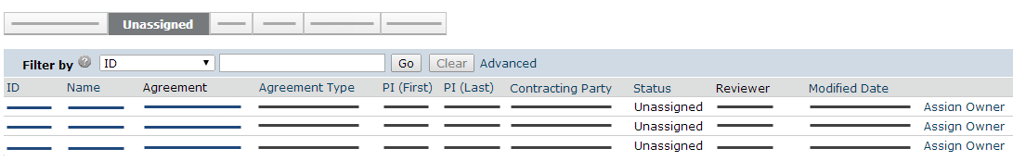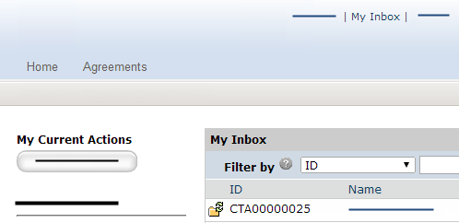  1  2  3  4  7  6  8  5 | Take or Assign Ownership
- In the top navigation, click Agreements.
- Click the Unassigned tab.
- Click Assign Owner link.
The agreement will appear in the owner’s inbox (My Inbox) whenever reviewer action is required.
 | Open an Agreement
- From My Inbox, click the agreement name.
- If the agreement is not in your inbox, click Agreements in the top navigation and locate the agreement on one of the tabs (All Agreements, Unassigned, etc.)
 | View the Current Status
 | - In the agreement workspace, see the status in the top left.
 | Take Action on the Agreement
 | - In the agreement workspace, click the appropriate activity link on the left.
 | View Agreement History
 | - In the agreement workspace, click the History tab.

Track and Manage Reviews
You can easily track agreement reviews and follow up with internal, 3rd party, and ancillary reviewers. All activities listed below are performed from the agreement workspace. See Open an Agreement for details.
Activities include:
- Changing agreement state to Internal Review or External Review to reflect who is reviewing the agreement (there
is no state for ancillary review, which may be occurring at the same time)
- Finding agreements in review and viewing the last action taken
- Creating reminders or action items for next steps
- Editing the agreement or uploading a revised or final agreement
- Following up with ancillary reviewers (see Manage Ancillary Reviews for activities specific to ancillary reviews)

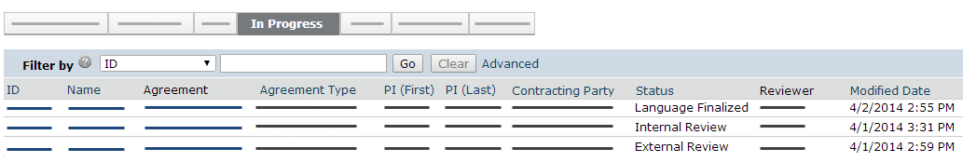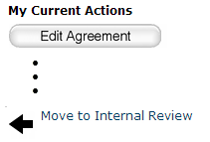  4a  3  4b  2  1 | Change Agreement State to Internal or External Review
 | - On the left, click Move to Internal Review or Move to External Review to reflect who is reviewing the agreement.
 | Find Agreements in Review
- In the top navigation, click Agreements.
- Click the In Progress tab.
- On the In Progress tab, see the following columns:
  - Status to find agreements in Internal Review and External Review
  - Modified Date to see when action was last taken on an agreement
Tip: Use the “Filter by” area to show only agreements in a certain status, such as, Internal Review.
- Open the agreement and review the history to see the last activity performed. See Open an Agreement and View Agreement History.

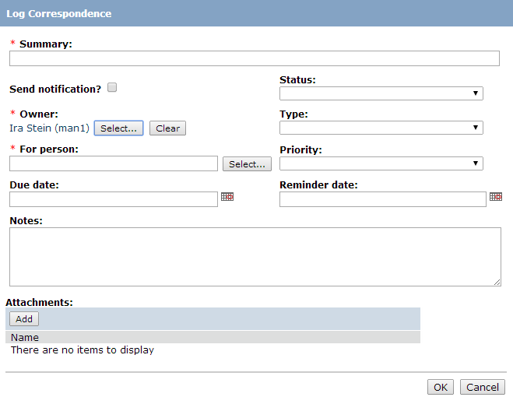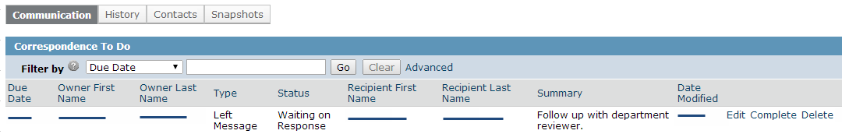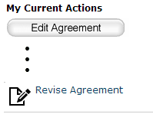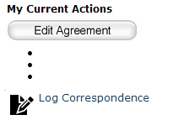  8  7  7  9a  9b  6 | Create and Update “To Do” Items
You can create “to do” items for yourself or other Agreements users, such as:
- A reminder to follow up with a reviewer
- An action item for an internal user to complete a review
- On the left, click Log Correspondence.
- Complete the form and click OK. Note: The system can notify the “For person” both when the item is created and on a reminder date.
- On the Communication tab, use the links to update items or mark them as completed.
 | Edit or Revise the Agreement
- To update an agreement, you can perform either of the following activities:
  - Edit Agreement to change the existing agreement
  - Revise Agreement to upload a revised or final agreement

Manage Ancillary Reviews
All activities listed below are performed from the agreement workspace. See Open an Agreement for details. To set reminders to perform ancillary review activities, see Create and Update “To Do” Items.
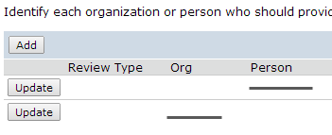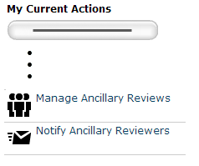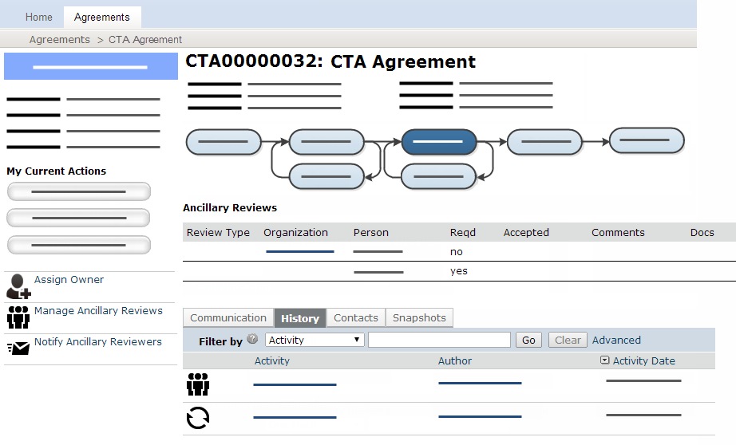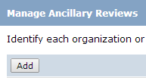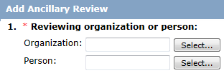  2  1  3  4  6  9  10 | View Ancillary Reviewers Assigned
On the History tab, the list of ancillary reviewers appears above the history log.
- Review the Reqd column. Required reviews must be completed before the agreement language can be approved.
 | Add an Ancillary Reviewer
- On the left, click Manage Ancillary Reviews.
- Click Add.
- Next to Organization or Person, click Select and then choose the organization or person. Click OK.
- Complete the rest of the form and click OK.
 | Notify Ancillary Reviewers
- On the left, click Notify Ancillary Reviewers.
- Select the reviewers you want to notify and type a message.
- Click OK.
 | Update an Ancillary Review
- On the left, click Manage Ancillary Reviews.
- Click Update next to the person or organization for the review you want to enter.
- Complete the form, indicating if the reviewer accepted the submission and click OK.

Wrap Up Agreement Review
After all internal, 3rd party, and required ancillary reviews are completed, the agreement language can be approved and the agreement signed. The following checklist includes the activities to perform to complete the review process.
All activities appear on the left of the agreement workspace (highlighted below).
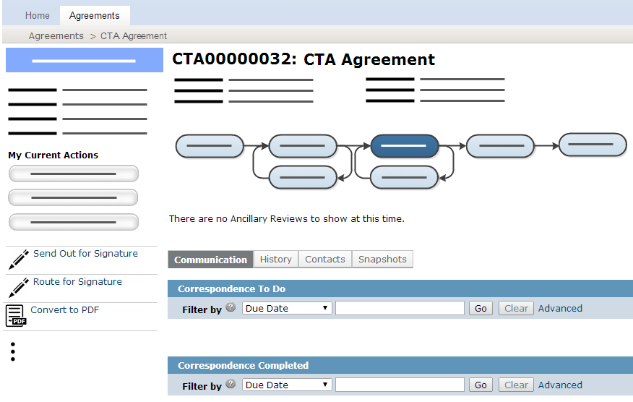 | - Approve Language: During this activity, you will indicate if the agreement will be routed for internal signature first.
 | - Convert to PDF: Depending on your system setup, this activity may also add a watermark to the PDF. Your institution may prefer you to convert to PDF after signatures have been received.
 | - Route for Signature: If you are routing for internal signatures first, then perform Send Out for Signature next.
 | - Send Out for Signature: If you are sending the agreement out for external signatures first, then perform Route for Signature next.
 | - Activate (or Approve for amendments): After all signatures have been received and the agreement is converted to PDF, perform this activity to complete the review process.

Lists key activities users may perform; See the Agreements software workflow diagrams for all activities users can perform in a particular state.
Agreements Managers can perform all the same activities as Agreements Reviewers.

