Submit an Agreement
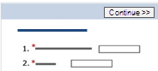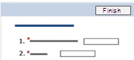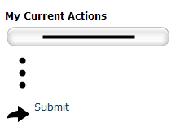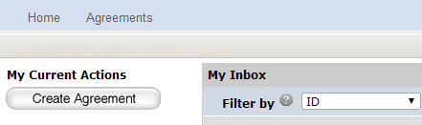  1  2  3  4 | - From My Inbox, click the Create Agreement button.
 | - Complete the pages. To move to the next page, click Continue.
 | - On the last page, click Finish.
 | - On the left, click Submit.
 | - Click OK to accept the statement and submit the agreement.

Assign an Ancillary Reviewer
You can add an organization or a person as an ancillary reviewer up until you submit the agreement.
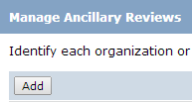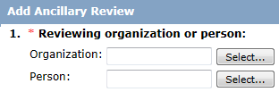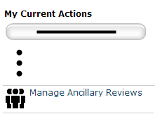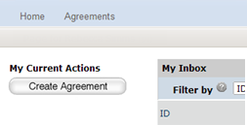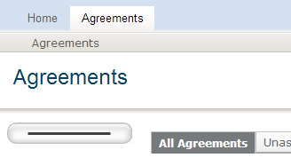  1  2  3  4  5 | - In the top navigation, click Agreements.
 | - Click the All Agreements tab and then click the agreement name to open it.
 | - On the left, click Manage Ancillary Reviewers.
 | - Click Add.
 | - Next to Organization or Person, click Select and then choose the specific organization or person. Click OK.
 | - Complete the rest of the form and click OK.
 | - To add more reviewers, click Add and repeat the steps.
 | - Click OK when done.

Respond to Reviewer Requests
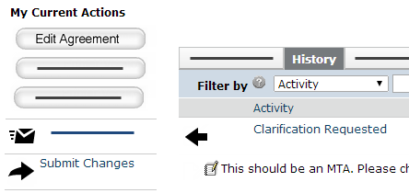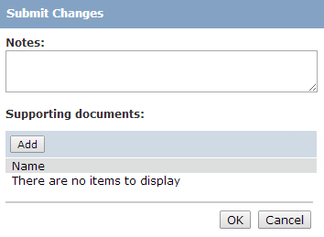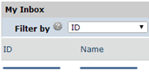  1  4  6  5  7  3 | - From My Inbox, click the agreement name to open it.
 | - Click the History tab.
 | - Look for the Clarification Requested activity and review any reviewer comments.
 | - To update the agreement, click Edit Agreement on the left and make the changes. If not, go to the next step. You will be able to enter a response for the reviewer before submitting.
 | - Click Submit Changes.
 | - (Optional) In the Notes box, type a response to the reviewer’s comments or questions.
 | - Click OK.

Create an Amendment
You can create amendments for agreements in the Active, Expired, and Evergreen states. Only one amendment can be in progress at a time for an agreement.
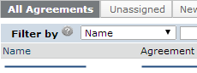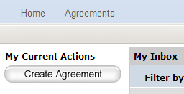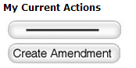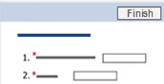  1  2  3  4  5 | - In the top navigation, click Agreements.
 | - On the All Agreements tab, click the name of the agreement to amend.
 | - On the left, click Create Amendment and complete the pages.
 | - On the last page, click Finish.
 | - On the left, click Submit.
 | - Click OK to accept the statement and submit the amendment.

