KBACE Kube Manager (KBX Client-Side 4.2.48 Installation)
Note: Access the KBX4.2.48.exe file by navigating to www.rfsuny.org and selecting Information For/Online Tools/KBACE and downloading the Installation Files and Installation Instructions. Click on the KBX4.2.48.exe file to start the installation process.

Local Administrator rights are required for this install. See end of document for Supported OS and Additional Programs.
Installation Instructions
Close all copies of MS Excel and click on the downloaded KBX4.2.48.exe. The InstallShield Wizard dialog appears. Click the ‘Next' button.
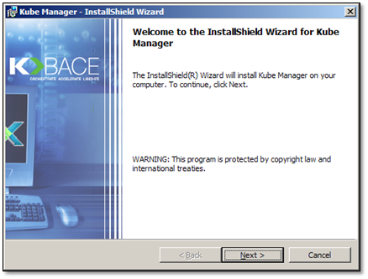
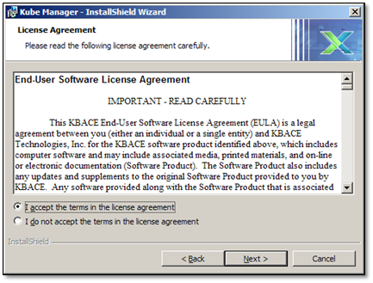
Select “I accept the terms in the license agreement”. Click the ‘Next’ button.
Enter information for the User Name and Organization fields.
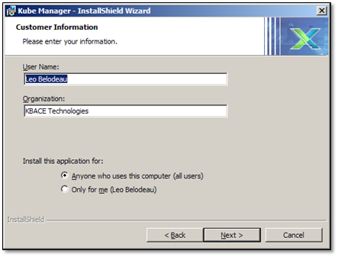
Install this application for:
Per Machine - Select the radio button "Anyone who uses this computer (all users)". Doing so places the KBX Kube Manager icon on each windows logon's desktop.
Per User - Select the radio button "Only for me (xxx)". KBX Kube Manager and icon will only be available to the installers logon. The installer must have administrator permissions.
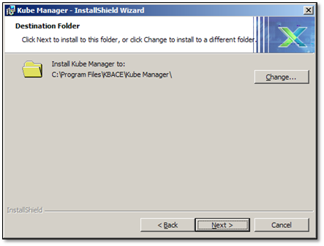
The default install location is displayed. You can change the install location by clicking ‘Change’ button. Click the ‘Next’ button to continue.
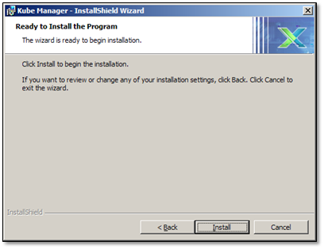
Click ‘Back’ if you need to change any of the install settings. Click ‘Install’ when you are ready to continue.
The install may take several minutes to complete. Once it is done click ‘Finish’.
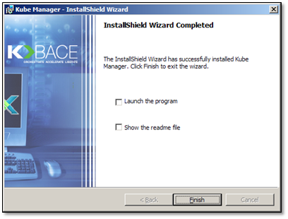
Reboot computer if prompted.
Additional Information
Kube Manager desktop is protected from alteration after publication using a DigiCert Trusted G4 Code Signing RSA4096 SHA384 2021 CA1. A screenshot of the Certificate follows.

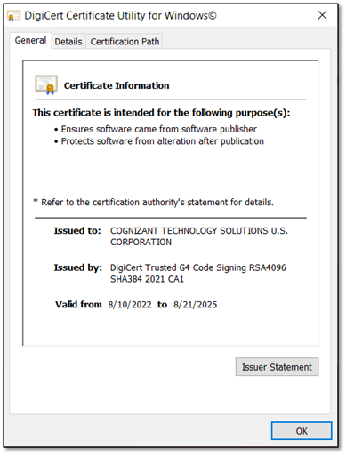
- Supported OS and Programs include Windows 10 and 11
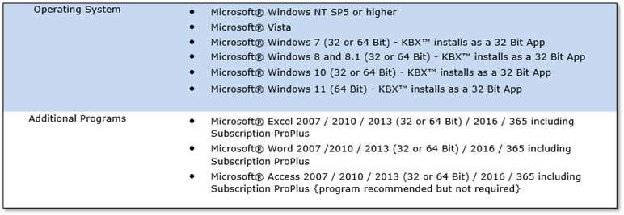

KBX MSSTDFMT.DLL Class not registered
When Windows DLL, MSSTDFMT.DLL is missing, KBX Kube Manager issues Error Number: 713. MSSTDFMT6432.exe installs and registers MSSTDFMT.DLL. MSSTDFMT6432.exe is digitally signed with Symantec VeriSign Code Signing (Class 3) SHA-2 Digital ID certificate.
Error Number 713

Sample the KBX Kube Manager error number 713.

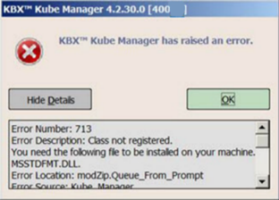

Installation Instructions
Download then click Setup as shown in the following screenshot to install.

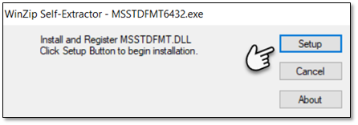
Example Registration Succeeded.
