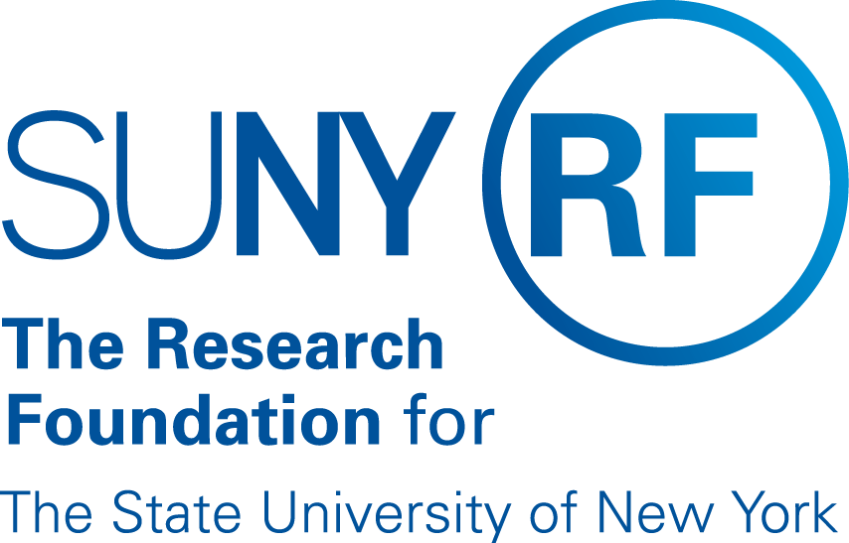

RF Report Center
Principal Investigator
Automatic Alert Notifications

Contents
Background 3
Terminology 3
How do the Alert Notifications Work? 3
How will the Security work? 4
Required Prerequisites 4
Campus Administration 4
Reports and Email Alert Notification Information 6

Date | Author | Change Reference
10/6/2015 | Kelly Kowalski | Created Document V1.0
11/4/2015 | Kelly Kowalski | Revised based on campus feedback. V1.2
1/5/2016 | Kelly Kowalski | Revisions based on UAT testing
9/13/2016 | Kelly Kowalski | Final Version for Implementation
10/18/2016 | Kelly Kowalski | Reviewed by Data Services Team.

RF Report Center
Automatic Alert Notifications

Background
The RF Report Center offers the ability to send automatic alert notifications to end users. An automatic alert notification is an email that can be sent to an end user that contains specific reports. The Principal Investigator automatic alert notification emails are sent to Award and Project Principal Investigators containing a report(s). The report(s) contain data from the alerts tab on the RF AIR and PI dashboards that is exported into an excel attachment and attached to an email automatic alert notification. The available reports with details are listed later on in this document.

Terminology
Alert: An alert is an event that is scheduled to trigger an email to be sent with a specific report attached at a scheduled time and date.

Designee: A person that will receive the alerts on behalf of an Award or Project Principal Investigator.

Prerequisites: Tasks that will need to be accomplished before the alert notifications are able to be sent and received successfully by the principal investigators.

How do the Alert Notifications Work?
Campus locations specify the reports that they would like sent to the Award and Principal PI’s or designees from the list below under the section Reports and Email Alert Notification Information at the end of this document by completing a form and sending an email with the completed form attached to Customer Services at customerservices@rfsuny.org.

The campus location can determine to send all of the listed reports or just a few reports. The campus will have the ability to discontinue or add additional reports at any time.

Note: The campus cannot choose to have specific reports sent to specific PIs.

After the campus location specifies the reports that they will be sending out, they will then need to determine what option they would like to choose for their campus on how they would like for the alert notifications to be sent.

Option 1 – Alert Notifications for Campus-Wide: Specify to have the alert notifications sent “campus-wide” meaning the reports will be sent to ALL of the Award and Project Principal Investigators for the entire campus location that meet the report criteria.

Option 2 – Alert Notifications for Individual PIs: Specify to have the alert notifications sent to specific Award and Project Principal Investigators. Campus administrator at the campus will have to manually go into the Award or Project PI records to accomplish this task. Instructions are provided later on in this document under Campus Administration.

How will the Security work?

The reports are returning data based on the security access of the Award or Project Principal Investigator. Please note that if the PI chooses to delegate another user to receive the reports on their behalf, and the user they choose does not have access to those awards, projects and tasks, or people data that is displayed on the report, the delegated user will also have access to that data. The data is not secured based on the delegate’s security access.

Required Prerequisites
- The Award Principal Investigator (Award PI) or Project Principal Investigator (Project PI) must have a human resources employee record with a valid email address entered in the office details tab in the email field as shown below in Figure 1.

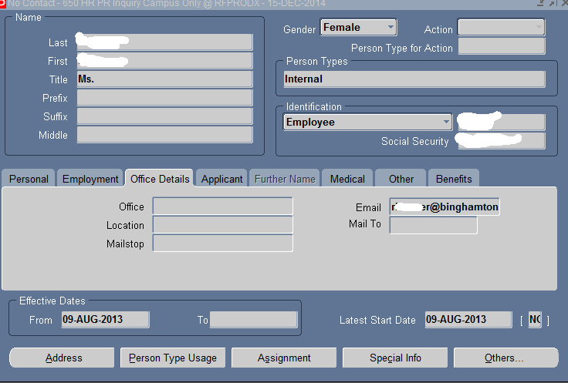

- The Award or Project PI must have access to the RF Report Center which includes a valid OBIEE responsibility and appropriate RUSAM access assigned. Details are listed below under Campus Administration.

- The Award or Project PI must have a role of Principal Investigator on an award or project.

Campus Action Items
The campus location will have to designate a campus administrator to complete the below procedures. The campus administrator will need to have the “XXX OBIEE Alert Options” responsibility assigned to them. (i.e. 160 OBIEE Alert Options). The campus will need to decide if they want the alerts to be turned on campus-wide or set up individual award and project PI’s to receive the alerts. The below steps defines each process.

Alert Notifications for Campus-Wide
- Complete the Campus Alerts Notification Request Form located on the public website under Report Center and send to customerservices@rfsuny.org.

- The reporting team will have an automatic script run for your location to have the alert notifications turned on.

- The RF Report Center team will communicate to the requestor when the request has been completed.

Alert Notifications for Individual PIs
The campus administrator will need to have the “XXX OBIEE Alert Options” responsibility assigned to them. (i.e. 160 OBIEE Alert Options).

- Choose the above listed responsibility for your location. Then navigate to the Campus OBIEE Email Notice > Enter the Information to search for the PI record by Full Name, Social Security or Employee number. Click Find.

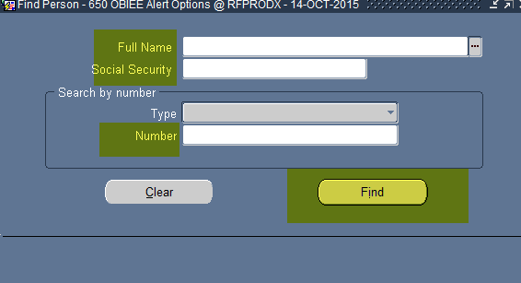

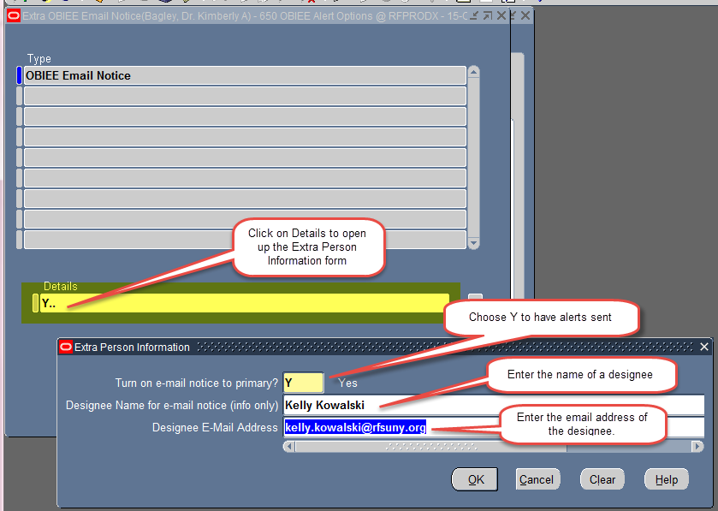

- Click on Details to enter the correct information into the Extra Person Information form as shown below.

  - Turn on e-mail notice to primary: User would select ‘Y’ for Yes to sign up for alert notifications.
    - To discontinue, the user would have to select ‘N’ for No to stop the alert notifications and clear out any fields with designee information.

  - Designee Name for e-mail notice: Optional field to type in the person name who will be the designee.

  - Design E-mail Address: Required field to enter the email address where the alert notifications will be emailed instead of the Award or Project PI.

Note: Leave the Designee fields blank if you want the alert to go to the PI.

- Click OK and the form will have information displayed in the Details field as shown below. Click SAVE or EXIT and then SAVE and exit the form.

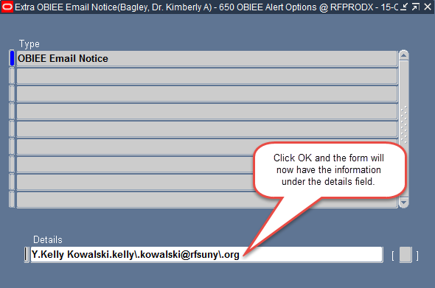
- The user is now set up correctly to receive alert notifications that have been turned on for your campus location.

- Once the end user is set up correctly in the system, an email will need to be sent to Customer Services with the Campus Alerts Notification Request Form completed and attached for the team to add your campus location to the alerts in the report center.

Reports and Email Alert Notification Information

Attached Report: Employees Terminating on a Grant in the Next 45 Days
Email Subject Line | Employees Terminating on a Grant in the Next 45 Days Monthly Alert
Email Text | The attached report lists employees terminating on a grant within the next 45 days based upon the employee’s labor schedule end date and task end date. Please review these reports to determine if there are necessary action items.  Note: Please do not reply to this e-mail as we are not able to respond to messages.
Email Alert Frequency | Every 30 days
Attached Report: New Person Assigned on a Grant in the Last 30 Days
Email Subject Line | New Person Assigned on a Grant in the Last 30 Days Monthly Alert
Email Text | The attached report lists new people that have been assigned on a grant within the last 30 days. Please review this list to ensure this is the correct information.  Note: Please do not reply to this e-mail as we are not able to respond to messages.
Email Alert Frequency | Every 30 days
Attached Report: New Awards or Projects Created in the Last 30 Days
Email Subject Line | New Awards Created in the Last 30 Days Monthly Alert
The attached report lists new awards along with budget information to initiate expenditure processing.
Note: Please do not reply to this e-mail as we are not able to respond to messages.
Email Subject Line | New Projects Created in the Last 30 Days Monthly Alert
Email Text | The attached report lists new projects and tasks along with budget information to initiate expenditure processing.  Note: Please do not reply to this e-mail as we are not able to respond to messages.
Email Alert Frequency | Every 30 days
Attached Report: Past Due Reports
Email Subject Line | Past Due Reports Monthly Alert
Email Text | The attached report lists reports that are showing as past due in the oracle system. Please review to ensure the grant is compliant according to the reporting requirements. If you find incorrect information, please contact your Grants Office.  Note: Please do not reply to this e-mail as we are not able to respond to messages.
Email Alert Frequency | Every 30 days
Attached Report: Awards Terming in the Next 90 Days
Email Subject Line | Awards Terming in the Next 90 Days Monthly Alert
Email Text | The attached report lists only sponsored program awards that are expiring within the next 90 days. Please review the available balance and encumbrance information to prepare for close out activities.  Note: Please do not reply to this e-mail as we are not able to respond to messages.
Email Alert Frequency | Every 30 days
Attached Report: Projects Terming in the Next 90 Days
Email Subject Line | Projects Terming in the Next 90 Days Monthly Alert
Email Text | The attached report lists only sponsored program projects and tasks that are expiring within the next 90 days. Please review the available balance and encumbrance information to prepare for close out activities.  Note: Please do not reply to this e-mail as we are not able to respond to messages.
Email Alert Frequency | Every 30 days
Attached Report: Reports Coming Due in the Next 90 Days
Email Subject Line | Reports Coming Due in the Next 90 Days Monthly Alert
Email Text | The attached report lists the reports entered on an award in the oracle system that will be due in the next 90 days to meet sponsor reporting requirements. Please review to ensure completion of the reports prior to the deadline dates.  Note: Please do not reply to this e-mail as we are not able to respond to messages.
Email Alert Frequency | Every 30 days

